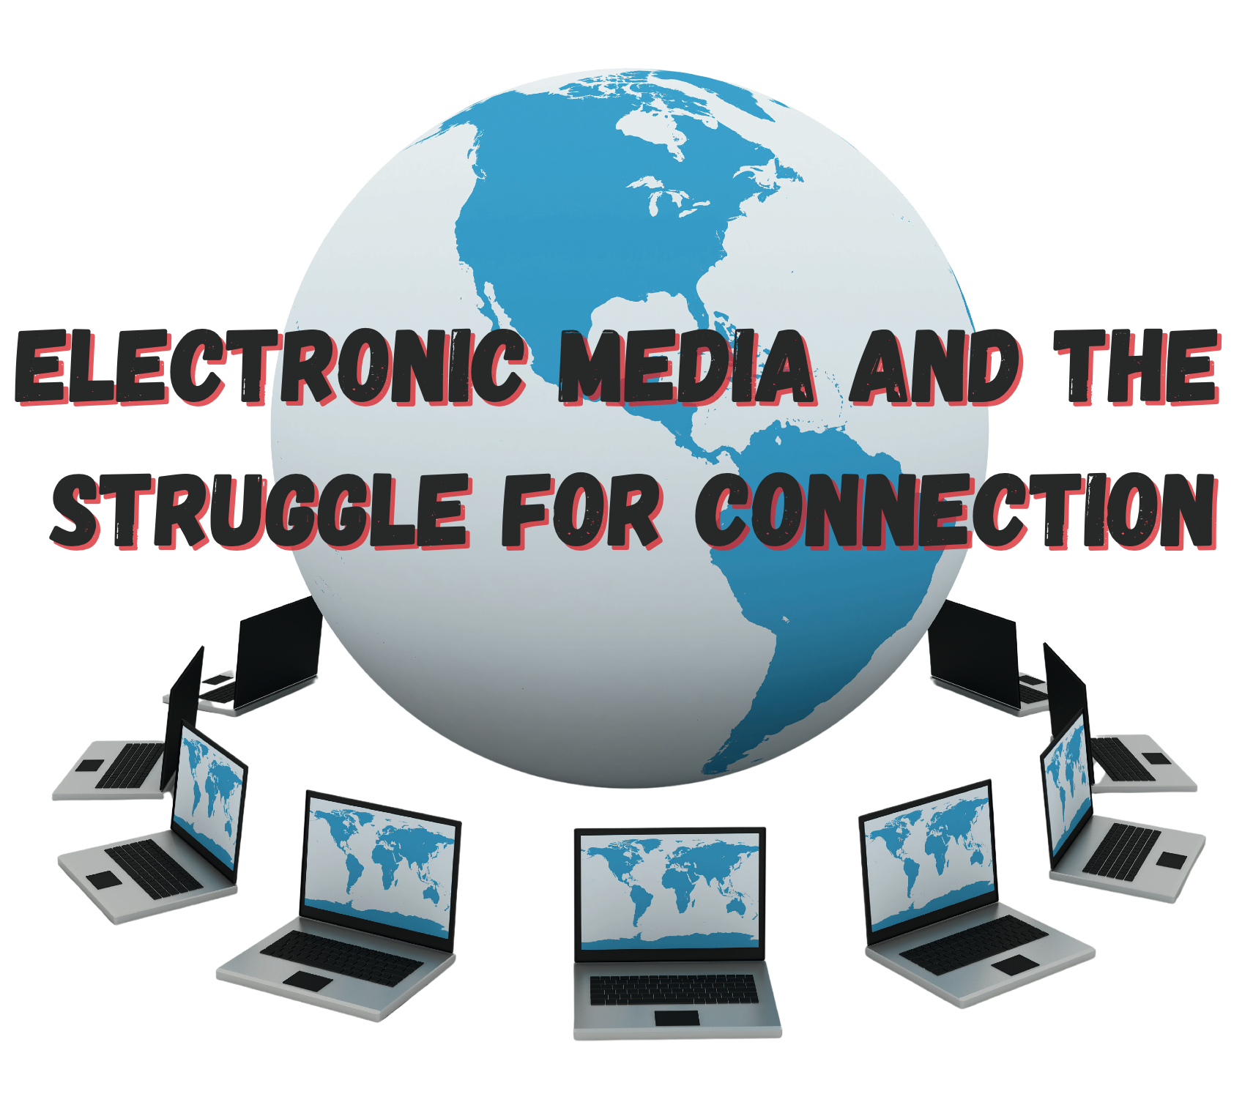
Jeffrey E. Hansen, Ph.D.
Pediatric and Adolescent Clinical Psychologist
Founder & Director, Center for Connected Living, LLC

Andrew P. Doan, M.P.H., M.D., Ph.D.
Aerospace Medicine Physician,
Ophthalmologist, and Neuroscientist

Electronic Media and the Struggle for Connection

By Jeffrey E. Hansen, Ph.D. and
Andrew P. Doan, M.P.H., M.D., Ph.D.

The views expressed in this book are those of the authors and do not necessarily reflect the official policy or position of the Defense Health Agency, Department of the Army, Department of the Navy, Department of Defense, or the United States Government.

NO MEDICAL ADVICE IS GIVEN NOR IS ANY PROVIDED IN THIS BOOK. SUCH INFORMATION WHICH MAY BE MEDICAL IN NATURE IS INFORMATION ONLY FOR THE USE OF LICENSED AND EXPERIENCED MEDICAL PRACTITIONERS. A READER INTERESTED IN MEDICAL ADVICE OR TREATMENT SHOULD CONSULT A MEDICAL PRACTITIONER WITH AN APPROPRIATE SPECIALTY WHO IS PROPERLY LICENSED IN THE READERS’ JURISDICTION.

Copyright © 2024 Jeffrey E. Hansen and

Andrew P. Doan

Published by the Center for Connected Learning, LLC
Prescott Valley, AZ 86314
Contents

Part 1: Introduction………..………..………..………………….. 1
Part 2: Some Facts and Terms………………..………..…….. 5
Part 3: How Does the Brain Get Hooked on Digital Drugs?………..…….…..……………………………………………… 14
Part 4: The Impact of Electronic Screen Media on
Your Child’s Brain, Body, and Behavior………………….. 24
Part 5: A Few Positives……………………………..……..…….70
Part 6: Treatment - How do We Fix this and Save our Children?…………………………………………………..……….… 74
Part 7: Closing Thoughts………………………………..….…107
Part 8: Media Contract………………………………..……… 109
Part 9: References…………………………………………..……114

Book Endorsements
This is an excellent book. It is easy to read, contains accurate, valuable information, and is very practical. As I read it, I thought "I want to give this to all my family members with young children". And I will.

Hilarie Cash, PhD, LMHC, CSAT, WSGC
Founding Member reSTART, Chief Clinical Officer (CCO),
Education Director

Child and adolescent psychologist Dr. Jeffrey Hansen and physician-neuroscientist Dr. Andrew Doan bring their half-century of professional expertise to bear on the problem of media addiction and its destructive effects on a child’s neurological and emotional development. Electronic Media and the Struggle for Connection presents a clear and detailed explanation of the e-media problem and its multifaceted causes and effects, inviting the reader to understand how excessive electronic screen connection causes human relational disconnectedness in children and adults. Drs. Hansen and Doan have crafted an inspiring and practical treatment section to guide parents through pathways for prevention and intervention for their children and themselves. This book is a must-read for guiding children and adults through the hazards and promise of the electronic screen age.
Andre Van Mol, MD
Board-certified family physician, Co-chair, Council on Adolescent Sexuality, American College of Pediatricians, Co-chair, Sexual and Gender Identity Task Force, Christian Medical &amp; Dental Assoc.

This is a “must-read” guide If you have a child or patient with ADHD, Anxiety, Bipolar disorder, IED or ODD. Drs. Hansen and Doan have written an invaluable guide for professionals and parents alike. Even after 30 plus years of experience, this book will guide my practice daily. Read this and learn from the best.

Salvatore Bitondo, LMSW, BCD

Chief, Family Advocacy Program, Behavioral Health Service Line, Madigan Army Medical Center, JBLM

There are only two lasting bequests
we can hope to bring our children,
one of these is roots, the other, wings.
- Johann Wolfgang von Goethe

Part One - Introduction

W
e have been in practice for over 55 years collectively and have been around long enough to appreciate that each new generation of kids comes with its own struggle of the times. Over the past 10 years or so, the children in Dr. Hansen’s former private practice in Olympia and, more recently, in his practice at Madigan Army Medical Center all too often presented with ever-increasing behavioral dysregulation to include extreme tantrums, aggression to peers and adults, destruction of property, negative mood, threats to harm self or others, and self-injury. As Dr. Hansen pondered what was happening, it has become increasingly clear that the common thread appeared to be an ever-growing consumption of media.

Dr. Doan is an ophthalmologist and an aerospace medicine physician with a Ph.D. in neuroscience. He spent three years with psychiatrists and psychologists to study media addiction. He sees children with developmental delays because their pediatricians want to rule out vision problems. Often, the children have excellent vision, but a media use history reveals a pattern of excessive media usage in the order of 8 to 10 hours daily. He has seen a phenomenon known as virtual autism that completely resolves when entertainment screen time is alleviated or significantly reduced.

We began reviewing the literature to see if anyone else had come to the same conclusion and found several seminal thinkers who have already been blazing the path toward a better understanding of what is really going on here:
- Cash, H. & McDaniel, K. (2008). Video Games and Your Kids: How Parents Stay in Control. Issues Press
- Doan, A. (2012). Hooked on Games. Coralville, IA: F.E.P. International, Inc.
- Dunckley, V. (2015). Reset your Child’s Brain. Novato, CA: New World Library.
- Hari, J. (2018). Lost Connections: Uncovering the Real Causes of Depression – And the Unexpected Solutions. Berryville, VA: Berryville Graphics, Inc.
- Kardaras, N. (2016). Glow Kids. New York, NY: St. Martin’s Press.
- Kersting, T. (2016). Disconnected: How to Reconnect our Digitally Distracted Kids. Independent Publishing Platform.
- Palladino, L. (2015). Parenting in the Age of Attention-Snatchers: A step-by-step Guide to Balancing Your Child’s Use of Technology. Boston, MA: Shambhala.
- Turner, A. (2017). Breaking the Feedback Loop: How I Liberated myself from Internet Addiction and you can too. Lexington, KY: Phanarian II.
- Wilson, G. (2014). Your Brain on Porn. UK: Commonwealth Publishing.
This book summarizes our thoughts as well as the amazing work of these seminal writers. We hope it will enable parents to appreciate that our children are in trouble, serious trouble, so deep, in fact, that, left unchecked, their futures and, in some cases, their very lives are at stake. But there is hope – new research is offering us a clear understanding of what is happening emotionally, neurologically, and psychologically to media-addicted children and well-thought-out parental guidance and, when needed, treatment protocols are being developed and successfully implemented.

In his book, Breaking the Feedback Loop, Turner (2017) bravely wrote of his own struggle with media addiction, an act which could have cost him his job security in the media industry. To quote, “I was living in Huxley’s future (as described in Brave New World). I couldn’t concentrate. I craved instant gratification. I had terrible habits. I carried around a nagging guilt. A deep sickness and anxiety. Despite being at an Ivy League school, I felt I wasn’t maturing. I wasn’t getting smarter, wiser, more capable, more outgoing, more socially competent. I felt my intelligence was weakening, slipping into a morass I couldn’t understand. My thinking was fragmented. I couldn’t write logically. All the work that had gone into my education was not resulting in any growth. I wasn’t working. I felt soul-sick. I lived on my computer. I didn’t take my learning seriously. Rather, I had lost my ability to do so…With my increasingly digital lifestyle, I continually spent less and less time reflecting, less and less time reading. I gobbled up more and more artificial information. I gorged on social media, pornography, click bait articles, TV shows, and movies. Over time my attention span shrank and weakened; I had the cognitive capabilities of a young child. I was overloaded with information but hollowed out inside. I lived in constant state of overstimulation. I had few mental resources available. I couldn’t engage with lectures, books, or papers that needed to be written. I felt overwhelmed with reality. I pursued distractions at the expense of my own development…I had a compulsion to constantly consume new artificial stimulants. I was addicted.”
Get your facts first,
then you can distort them as you please.
- Mark Twain

Part Two - Some Facts and Terms

V
ictoria Dunckley (2015) in her book, Reset your Child’s Brain, Thomas Kersting (2016) in his book, Disconnected, and Nicholas Kardaras in his book, Glow Kids (2016), ask us to consider some startling emerging trends:

- In a ten-year span from 1994 to 2003, the diagnosis of bipolar disorder in children increased forty-fold (Moreno, C., et al., 2007).
- Childhood psychiatric disorders, such as ADHD, autism spectrum disorders, and tic disorders are on the rise (Atladottir et al., 2007).
- Dr. Victoria Dunckley is a pediatric psychiatrist, and her clinical observations are eye-opening. Between 1980 and 2007, the diagnosis of ADHD has increased by 800 percent (Dunckley, 2012).
- A December 2015 study in the Journal of Clinical Psychology found that ADHD diagnoses rose 43 percent in the United States, with more than one in ten children now diagnosed with the disorder.
- Between 2001 and 2005, ADHD medication prescription rose by 40%.
- Mental illness is now the number one reason for disability findings for children, representing half of all claims filed in 2012, compared to just 5 to 6 percent of claims twenty years ago (SSI Annual Statistical Report, 2012).
- Childhood psychosocial and neurodevelopmental issues have increased proportionally with the insidious growth of electronic screen exposure in daily life. Children two to six spend two to four hours per day screen-bound during a period of their lives when sufficient healthy play is critical to normal development (Rideout et al., 2004).
- Computer training in early education, including preschool, has become commonplace, despite a lack of empirical support for its efficacy (Facing the Screen Dilemma: Young Children, Technology, and Early Education, 2012)
- According to a long-term study by the Kaiser Family Foundation in 2010, children 8 to 18 spend on average 7½ hours per day on some form of screens – a 20% rise from just five years earlier (Rideout et al., 2010).
- 8 to 10-year-old children spend nearly eight hours per day on media and older children spend more than 11 hours (AAP, 2013).
- Our children spend more time with media than in school, and media is only second to sleep as the primary activity (AAP, 2013).
- 71% of children have a TV or Internet device in their room (AAP, 2013).
- Teens receive and send on average 3,705 texts per month or about six per hour (Rosen, 2012)
- An 11-year-old today is performing at the level that an 8 or 9-year-old was performing at 30 years ago. (Shayer et al., 2007).

Dunckley (2015) remarked, “In 2013, a controversial new diagnosis – Disruptive Mood Dysregulation Disorder (DMDD) – was introduced in the DSM-5. The presentation of a child with chronic irritation, poor focus, rageful behavior, meltdowns, and oppositional-defiant behavior was more commonplace, and there is legitimate concern that these children are being misdiagnosed with bipolar disorder or other conditions and are being prescribed antipsychotic medication. In the face of such diagnoses, psychiatrists felt it was necessary to define a new disorder that more accurately matches these children’s symptoms, despite a lack of definitive proof that these symptoms indeed represent a true organic mental health disorder.” She goes on to conjecture, “But what if this ‘disorder’ characterized by dysregulation is not some mysterious new plague, but environmentally related? If we ask ourselves, ‘What is the biggest change in our children’s environment compared to only one generation ago?’ the answer is not gluten, pesticides, plastics, or food dye, but the advent of the Internet, cell phones, and wireless communication. Might DMDD really be a by-product of constant bombardment from electronic screen devices, causing the brain to short-circuit? And what if the systematic removal of such screen devices provided much-needed relief, almost immediately?”

Electronic Screen Syndrome (ESS), as defined by Dunckley (2015), is a constellation of symptoms from exposure to electronic screens as characterized by a state of hyperarousal (fight or flight) and mood dysregulation. ESS is essentially a disorder of dysregulation. Due to the overstimulating nature of interactive screen time, the nervous system shifts into fight or flight mode, which leads to dysregulation and disorganization of various biological systems. Sometimes, this stress is immediate and obvious, such as while playing a video game. At other times, the stress response can be subtler and gradually occur from repetitious screen interaction, such as frequent ongoing texting and social media consumption. Finally, it might be delayed only to erupt after years of screen time have accumulated. Regardless of which pathway, repeated fight-or-flight overstimulation of the nervous system from electronics will often result in a very dysregulated child. Dunckley (2015) notes that one way of thinking about ESS is to view electronics as a stimulant (in essence, not unlike caffeine, amphetamines, or cocaine). Electronic screens put the body into a state of high arousal and hyperfocus, which is then followed by a “crash.” This type of overstimulation can cause various chemical, hormonal, and sleep disturbances in exactly the same way as other powerful stimulants can. More importantly, just as a drug can affect the user long after stopping the drug and all traces of the drug in question are out of the body, excessive electronic media consumption can impact the central nervous system long after the offending device has been removed. In fact, abuse and addiction to stimulant drugs such as methamphetamines and cocaine have a curiously similar presentation to ESS, including mood swings, difficulties in concentration, and a narrowed range of interests outside of the substance or activity of choice.

Warning signs of ESS (Dunckley, 2015):
- Is revved up all the time
- Has meltdowns over minor frustrations
- Has full-blown rages
- Becomes irritable when asked to stop playing video games or to get off the computer
- Pupils are dilated after using electronics
- Hard time making eye contact after screen time or in general
- Attracted to screens – like a moth to a flame
- Less happy than normal or a loss of interest in otherwise pleasurable activities (anhedonia)
- Difficulty making or keeping friends
- Narrowed range of interests, or that these interests mostly revolve around screens
- Thirst for knowledge and natural curiosity have dampened
- Grades have fallen and/or is not working up to potential
- Teachers, pediatricians, or therapists have suggested ADHD, bipolar disorder, depression, anxiety disorder, or possibly even psychosis, and there is no family history of the disorder
- Multiple practitioners have given differing or conflicting diagnoses
- Preexisting conditions such as autism spectrum disorder or ADHD appear to be getting worse
- Is “wired and tired,” like being exhausted but can’t sleep, or sleeps but doesn’t feel rested
- Seems lazy and unmotivated and has poor attention to detail
- Seems stressed, despite no evident stressors
- Receiving services at school, but they don’t seem to be helping

Screen time (Dunckley, 2015):
Screen time refers to any and all time spent in front of any device that involves a screen to include:
- Computers
- Cell phones
- Televisions
- Video games
- Laptops
- Tablets
- Digital cameras
- E-readers

This encompasses any screen-related activity be it for work, pleasure, or school to include:
- Time spent texting
- Video chatting
- Surfing the Internet
- Gaming
- Emailing
- Engaging in social media
- Using apps
- Shopping online
- Writing and word processing
- Reading from an electronic device such as a tablet or Kindle
- Scrolling through pictures on a phone

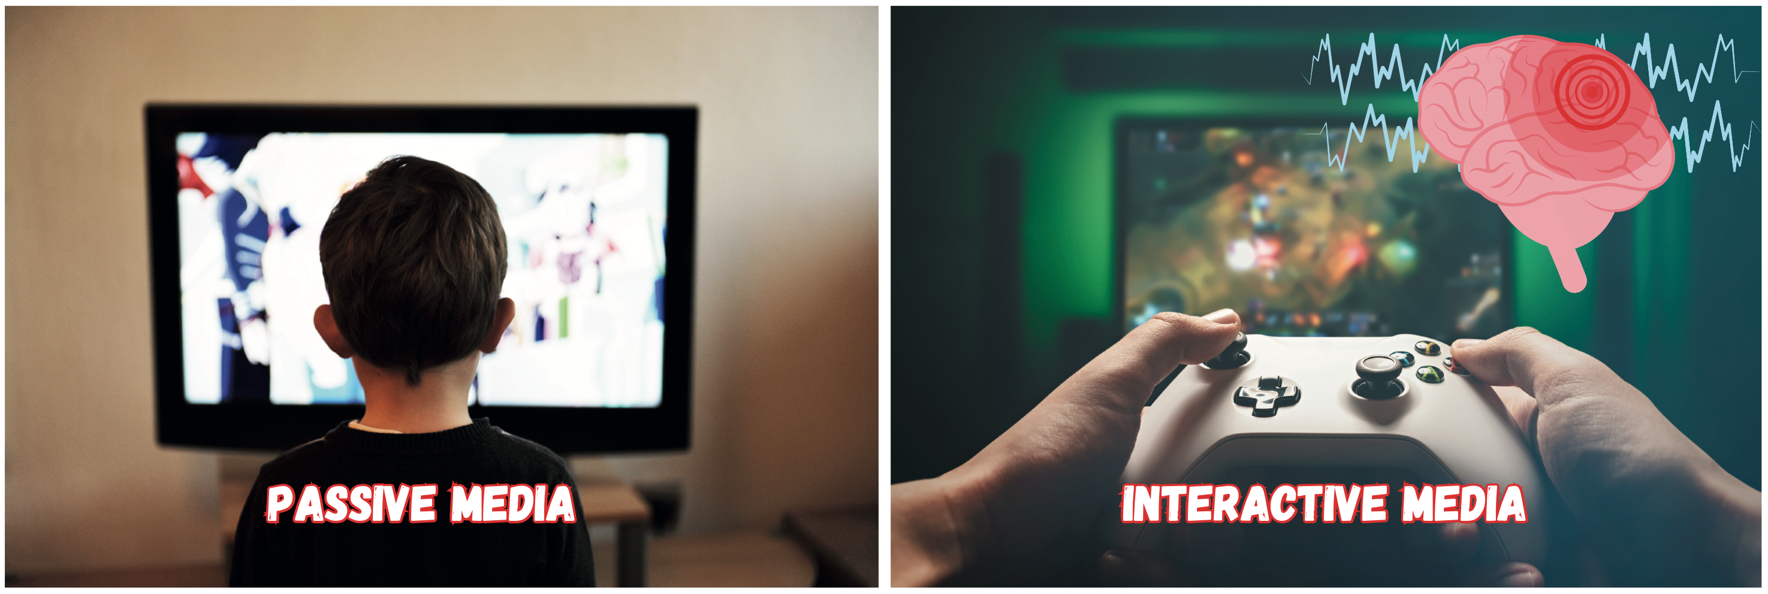
According to Dunckley (2015), interactive screen time involves screen activity whereby the user regularly interfaces with an electronic device, whether it is a touch screen, keyboard, console, motion sensor, etc. On the other hand, passive screen time refers to activities such as watching programs on a TV across the room. These days, parents often let their children watch TV shows on handheld devices such as a laptop or iPad, and this type of viewing of media is substantially more stimulating and dysregulating and, as such, is considered interactive screen time. Over the last several decades, the scene changes in media and videos online have increased in frequency to every three to four seconds to capture our attention. Dr. Dimitri Christakis, a pediatric developmental specialist, states that rapid scene changes in media increase stimulation and are associated with rising ADHD rates. Dunckley (2015) notes there is a growing body of research that both forms of screen time are connected with health problems and developmental issues, such as obesity, depression, sleep problems, attentional problems, slower reading development, and decreased creativity, etc. Moreover, the research is becoming clearer that interactive screen time is intensely more problematic than passive screen time, a critical point as many parents believe the opposite is true and make efforts to limit passive screen time rather than active as they wrongly conclude that screen time which engages the child’s brain is better. However, this “interaction” is one of the most salient factors contributing to hyperarousal, and, as such, any potential benefit from the “engaging” activity is overridden by “stress-related” reactions. For example, as cited in Dunckley’s book, a 2012 study surveying the habits of over 2,000 elementary school and junior high students found that the minimum amount of screen time associated with sleep disturbance was just 30 minutes for interactive (computer or video gaming) compared to two hours for passive media (TV).
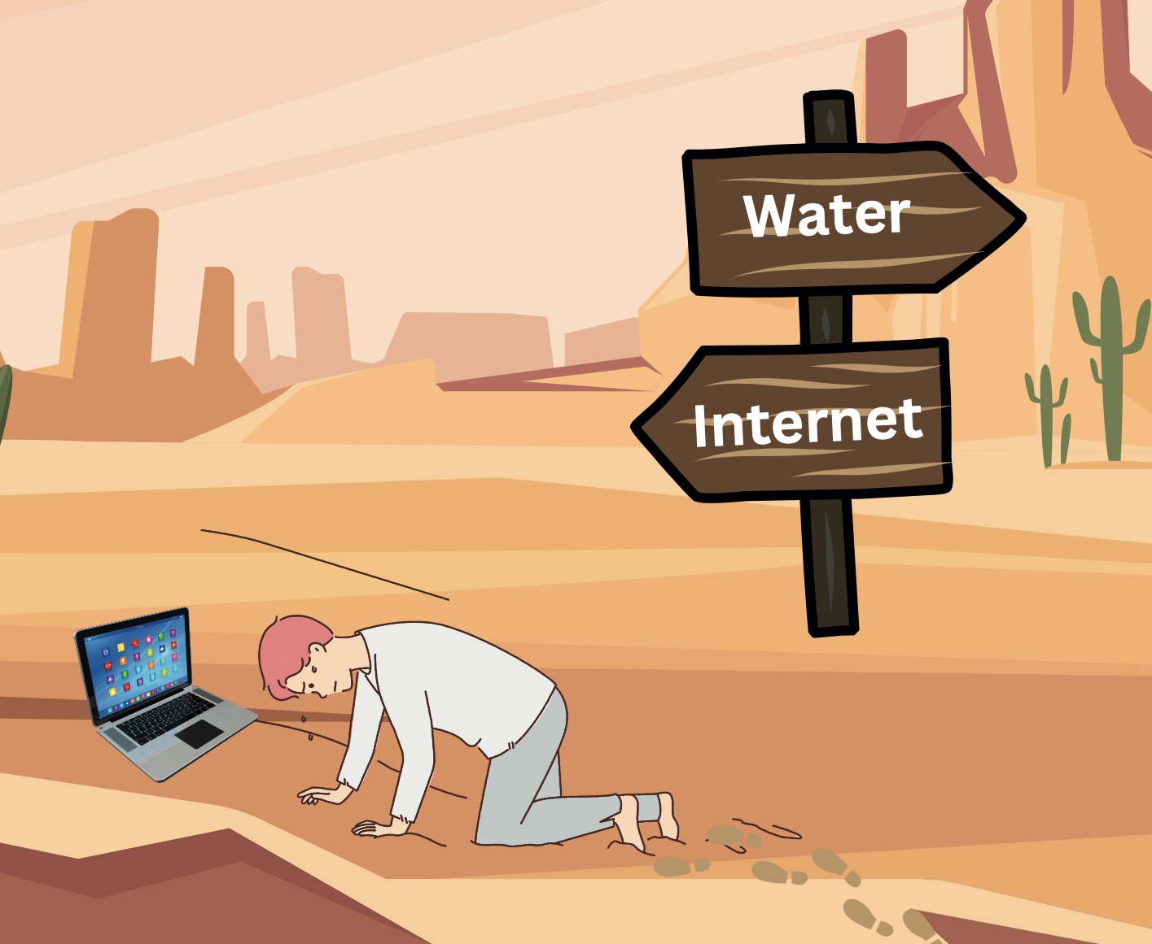

Men have become the tools of their tools.
- Thoreau

Part Three - How does the Brain Get Hooked on Digital Drugs?

A
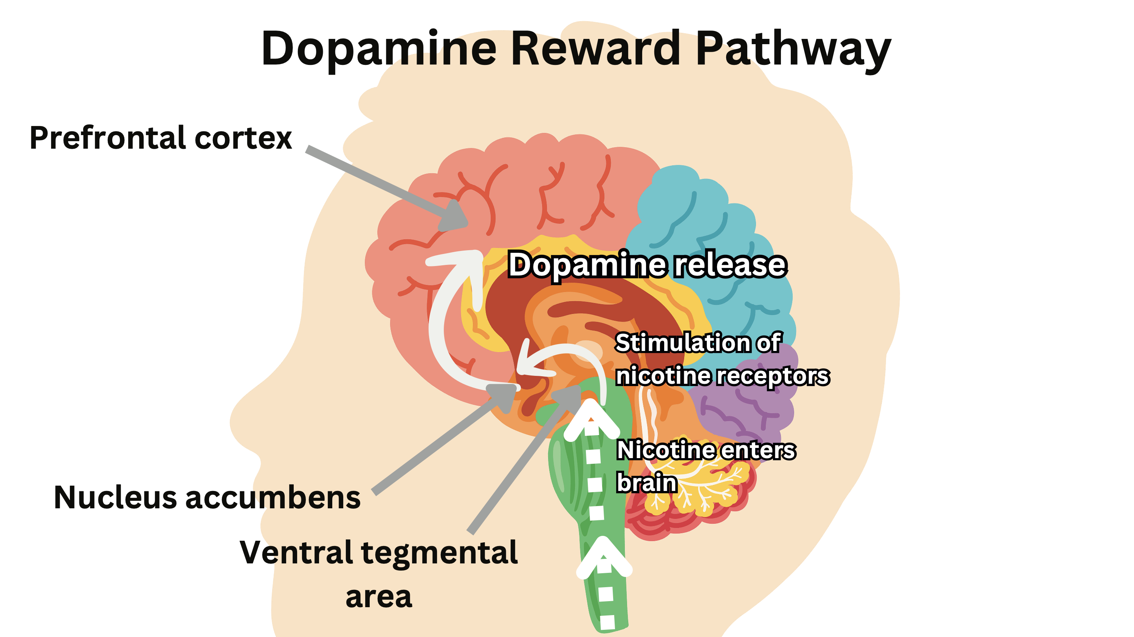
s Kardaras (2016) stated in his book, Glow Kids, in order to fully understand addiction, we need to understand the brain’s reward system and the impact of dopamine on that reward pathway.
Specifically, how much a substance or behavior activates dopamine is correlated directly with the addictive potential of that substance or behavior. Dopamine, as many of us know, is the “feel-good” neurotransmitter that is the most critical part of the addiction process. Dopamine was discovered in 1958 by Arvid Carlsson and Niles-Ake Hillarp at the National Heart Institute of Sweden. As also noted by psychologist Dr. Susan Weinschenk (2009), dopamine is created in various parts of the brain and is critical in several brain functions to include:

- Thinking
- Moving
- Sleeping
- Mood
- Attention
- Motivation
- Seeking and reward

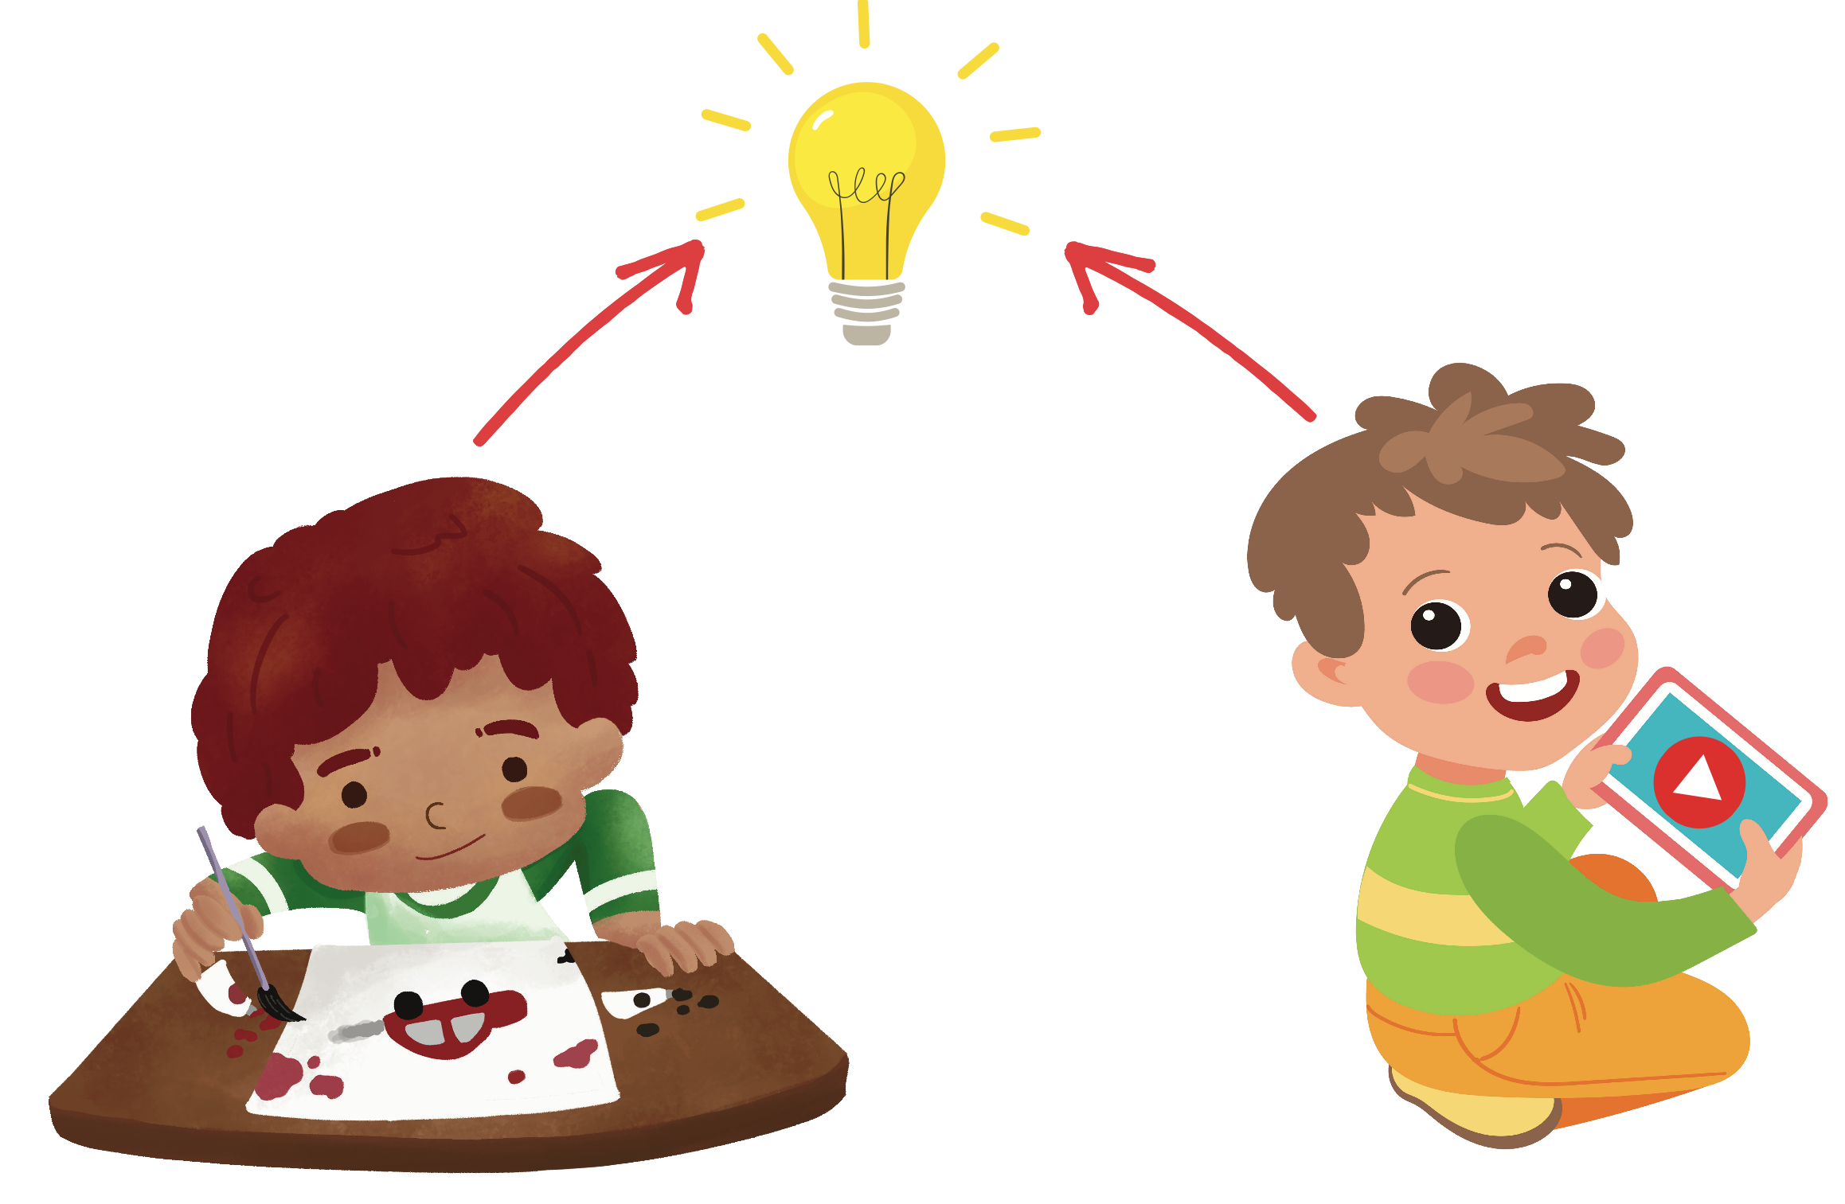
Inspired to watch because of dopamine.

When an individual performs an action that satisfies a need or fulfills a desire, dopamine is released into the nucleus accumbens, a cluster of nerve cells beneath the cerebral hemispheres specifically associated with reward and pleasure. This is also known as the brain’s “pleasure center.” Basically, engaging in a pleasure-seeking behavior increases dopamine levels so that the dopamine pathway is activated, which tells the person to repeat what s/he just did to continue that “feel-good” sensation or, as Kardaras calls it, “the dopamine trickle.” From an evolutionary perspective, this dopamine trickle is an important survival mechanism as it rewards and, thus, incentivizes essential and important biological and social functions, such as eating, procreation, love, friendship, and novelty seeking. Natural dopaminergic activities, such as eating and sex, usually come after effort and delay and, as previously mentioned, serve a survival function. These are called the “natural rewards” as contrasted with addictive chemicals/behaviors (which can hijack the same circuity). In other words, addictive drugs and behaviors, such as gambling and video gaming, actually offer a short-circuit to this process, which only ends up flooding the nucleus accumbens with dopamine and does not serve any biological function.

As Wilson (2014) points out, the evolutionary purpose of dopamine is to motivate you to do what serves your genes. The bigger the dopamine hit, the more you want or even crave the goal. Dopamine surges are the barometer in determining the potential value of any particular experience. Moreover, dopamine tells you what to remember by rewiring your brain by new and even stronger nerve connections.

Although dopamine has been referred to as the “pleasure molecule,” it is actually more about seeking and searching for pleasure rather than pleasure itself. Dopamine is more involved in drive and motivation to seek. The “final reward,” or what we experience as feelings of pleasure, Wilson (2014) writes, involves the release of endogenous opioids. You can think of dopamine as “wanting” and opioids as “liking.” As psychologist Dr. Weinschenk explains, dopamine causes us to want, desire, seek out and search; however, the dopamine system is stronger than the opioid system, and hence, we seek more than we are as satisfied…” Seeking is more likely to keep us alive than sitting around in a satisfied stupor. (Weinschenk, 2009). “Addicts want it more but gradually like it less. Addiction might be thought of as wanting gone amok.” (Wilson, 2014).

Wilson (2014) goes on to explain that the neurological process does not stop there. Highly salient activities, in this case, addiction, lead to the accumulation of DeltaFosB, a protein that activates the genes involved with addiction. The molecular changes it potentiates are almost identical for both sexual conditioning and chronic drug use. Specifically, DeltaFosB rewires the brain to crave IT whatever IT is. This is quite adaptive in situations in which survival is furthered by overriding satiation mechanisms (e.g., ‘I’m full, I’m done.”). In terms of survival of the species, Wilson points out that excess food or sex signals the brain that you have hit the “evolutionary jackpot,” and a powerful incentive kicks in gear. For example, wolves, which need to stow away huge amounts of food (up to twenty pounds) of a single kill will continue to consume their kill even though they are full. This is particularly salient in porn addiction. In a sense, dopamine is like the foreman on a construction site barking orders, and DeltaFosB is the worker on the site. Dopamine is yelling, “This activity is really important, and you should do it again and again” (Wilson, 2014). DeltaFosB is responsible for ensuring that you remember and repeat the activity. This repeated process produces sensitization, based on the principle, “Nerve cells that fire together, wire together.” Repeated activity strengthens cell connections.
DeltaFosB says, “Remember it and go for it!”

As the brain recognizes that it needs a rest, it will kick out CREB to slow things down. In essence, DeltaFosB acts like the gas pedal, and CREB functions as the brakes. It specifically inhibits dopamine and endogenous opioids to take the joy out of the binging/addictive behavior or substance so that you can give it a rest (Wilson, 2014). This numbed pleasure response induced by CREB is often identified as desensitization, which leads to tolerance - the need for increasingly higher doses to achieve the same effect. Tolerance is a key factor in addiction (Wilson, 2014).

While CREB can help to perhaps curb less sensational behaviors, such as too many portions of a good meal, it has little chance against high valence substances like cocaine, porn media, and intense game media. This leads to what Wilson (2014) calls “nature’s cruel joke.” Specifically, CREB’s attempt to suppress dopamine and natural/endogenous opioids is insufficient to shut down the process in highly salient addictions/behaviors in today’s world. Therefore, the person’s pleasure response is not sufficiently attenuated, so they are driven to more extreme addiction behavior. In other words, CREB can lead to tolerance, which can result in more compulsive use and escalation, which is particularly salient in porn addiction.

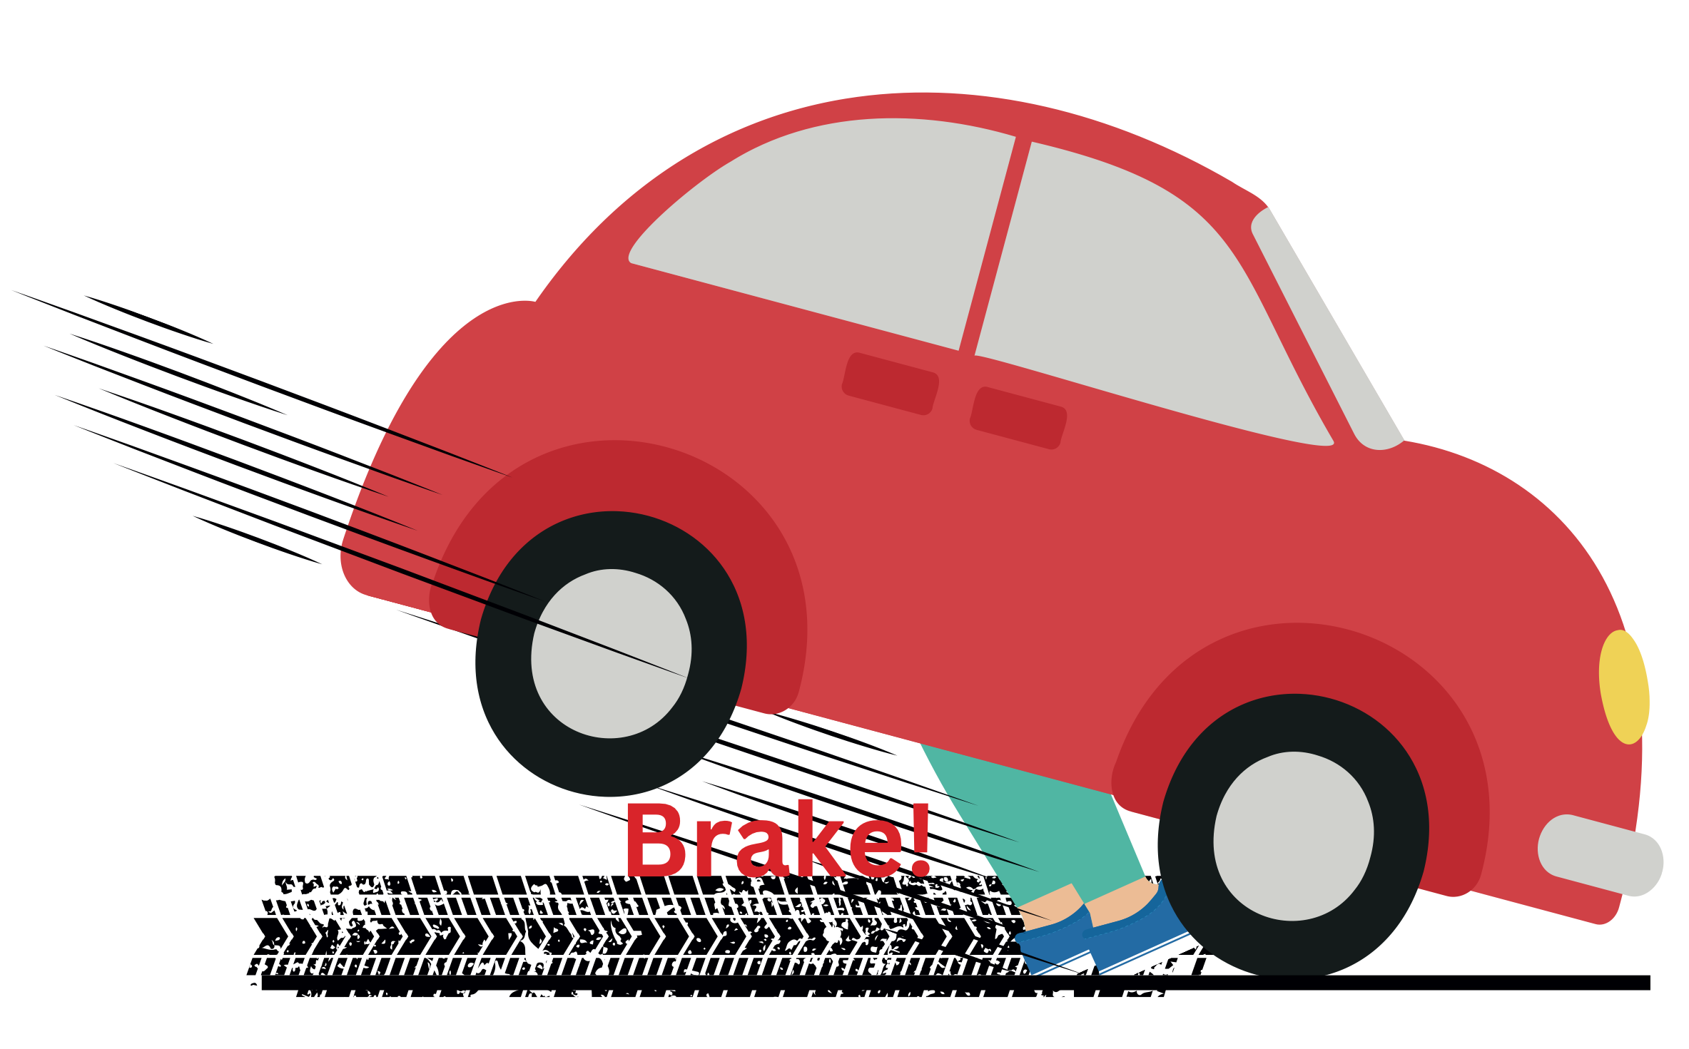
CREB says, “Slow it Down!”

So, we see that chronic overstimulation can lead to two opposite effects:
- Increased dopamine activity (wanting/seeking it more) – sensitization via DeltaFosB
- Decreased dopamine and opioid activity (liking it/enjoying it less) – via desensitization via CREB

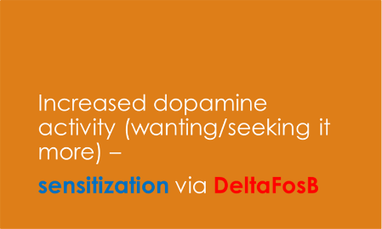

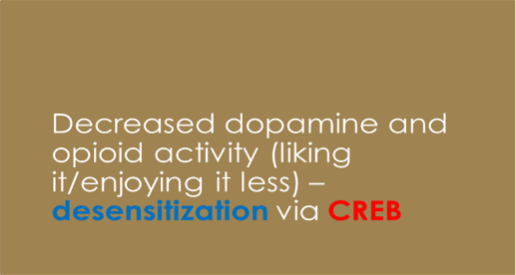

Sadly, the evolutionary process has not provided any way to withstand that onslaught of dopamine. When people become addicted, they experience a reduction of dopamine or a shutdown of dopamine to give some reprieve to the overwhelmed receptor cells. So, with this reduced capacity to produce dopamine naturally, the addicted individual enters a vicious cycle whereby he needs to ingest increasing amounts of the addictive substance in question or engage in the addictive behavior in question just to maintain his dopamine level (Wilson, 2014).

Then, as a “double whammy,” this chronic exposure to addictive behaviors or substances negatively impacts on the prefrontal cortex, which, among other things, is the brain’s decision-making center associated with impulse control or “braking mechanism.” As the prefrontal cortex’s braking mechanism becomes increasingly impaired, the person is far less able to put on the brakes and refrain from the addictive substance or behavior (Wilson, 2014).

Wilson (2014) notes that all addictions, regardless of their differences, result in an established set of “core brain changes,” which, in turn, present as recognized signs, symptoms, and behaviors such as those listed in the Three C’s:

- Craving and Preoccupation with obtaining, engaging in or recovering from the use of the substance or behaviors in question.
- Loss of Control in using the substance or of engaging in the behavior and noted by increasing frequency or duration, larger amounts or intensity, or increasing the risk and behavior to obtain the desired effect.
- Negative Consequences in physical, social, occupational, financial, or psychological areas.

Kardaras (2016) points out that certain substances or behaviors “trickle” dopamine more than others. For example, brain imaging research reveals certain foods and activities raise dopamine by the following amounts (Koepp et al., 1998; Guangbheng et al., 2012):

- Chocolate – 50% increase
- Sex – 100% increase
- Snorting cocaine – 350%
- Crystal meth – 1,200%
- Video gaming – 100% (keep in mind that this finding was based on a 1998 study when video gaming was relatively mild by today’s standards, and the increase might be much more with current gaming media).

Dopamine release activity
Normal brain Brain of obese person Brain of cocaine user Brain of alcoholic
This slide displays areas of brain activity after showing video game addicts triggers consisting of video game footage. The areas of activation occur in similar patterns in brains of people addicted to drugs and gambling.

I like to play indoors better, ‘cuz
that’s where all the electrical outlets are.
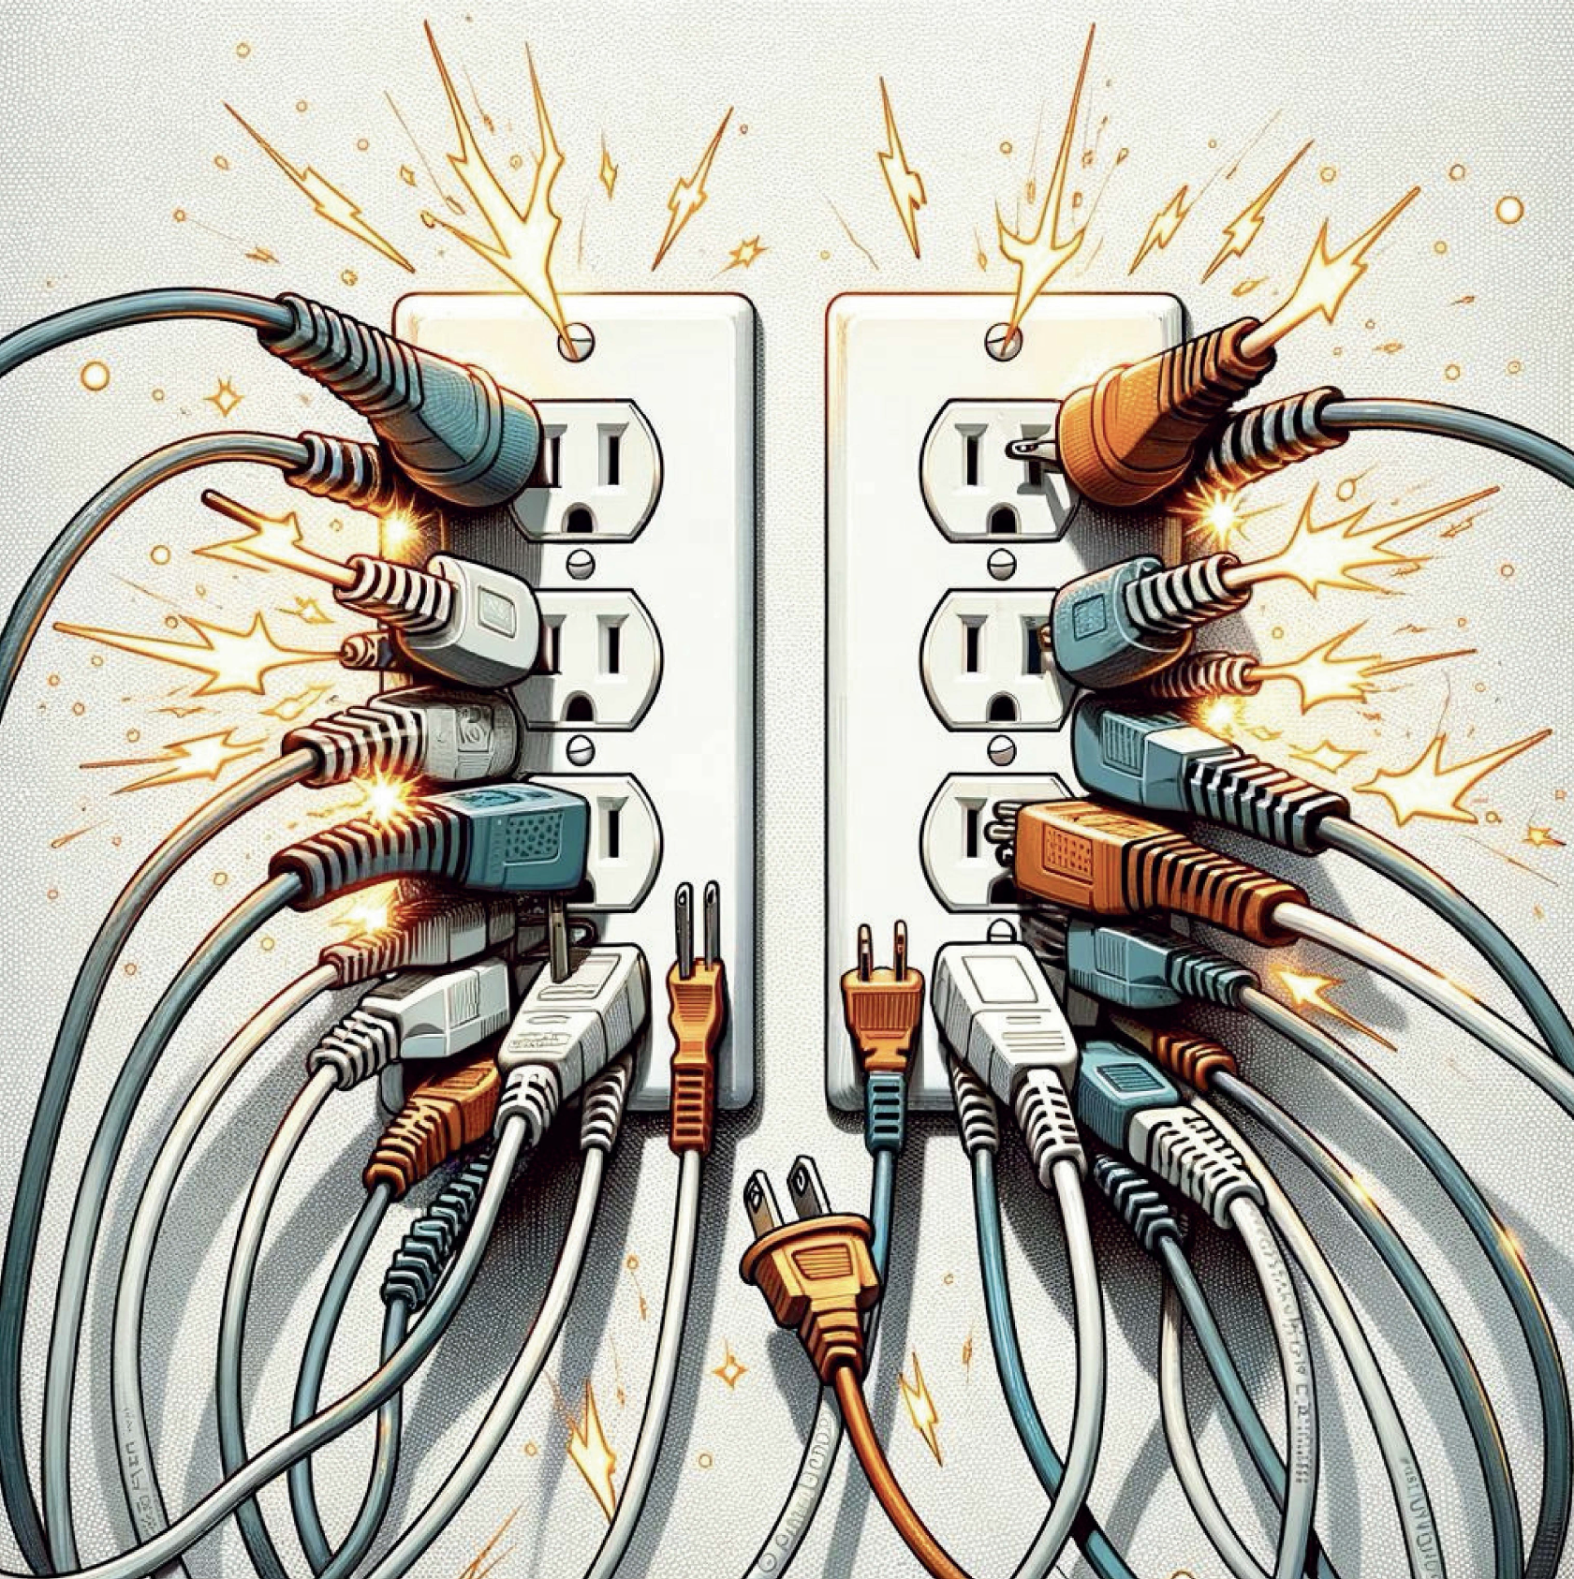
- Paul, fourth grader in San Diego

Part Four - The Impact of Electronic Screen Media on your Child’s Brain, Body, and Behavior

The Eyes:
A
s noted by Dunckley (2015), the eyes provide a very potent route for electronic screen toxicity, regardless of the content being processed. The eyes are the only part of the central nervous system directly exposed to the outside world. Directly behind each eye are the retina and the optic nerve, which take in information in the form of light. The optic nerve extends back from each eye and then crosses at the base part of the brain, where it then communicates with the pineal gland, which has as its main job to help regulate the sleep-wake cycles by secreting melatonin which is triggered by darkness. The unnaturally bright and excessive light of screens dysregulates this system and disrupt and desynchronize the body clock and other important biological rhythms. Dunckley (2015) also notes that interacting with media alters normal eye movements to include those used for changes in depth perception, which influences visual and vestibular (balance and body position) development, cognition, and mood regulation. Finally, the eye itself can possibly suffer as well. Dunckley notes that in addition to eye strain, “computer vision syndrome” results in blurred vision, headaches, and dry, irritated eyes. In some laboratory and animal studies, the LED light emitted from screens has been implicated in actual damage to the retina, specifically blue light and intense light. Screen time has also been found to correlate with a narrowing of retinal blood vessels, which is a marker for cardiovascular disease (Dunckley, 2015).
The brain is wider than the sky.
- Emily Dickinson

The Brain:
Dunckley (2015) writes that the brain is evolutionarily designed to respond to stimulating input – brightness, color, contrast, and movement - called the orienting response. The orienting response helps us assess a threat before we determine to fight or flee. However, when these stimuli are artificially created, the brain’s orienting response gets hijacked, which, in turn, creates chemical, electrical, and mechanical shifts that raise arousal levels, and, as this happens repeatedly, the brain stays on heightened alert. In addition, as noted above, the natural reward pathways, most specifically dopaminergic, are altered in the brain.

Kardaras (2016) notes that the overstimulation of the glowing lights and flashing lights of screens can damage myelin in neural pathways. Myelination is an important process that insulates nerve cell axons to increase the speed at which information travels from one nerve cell to another. The myelinated axon can be likened to an electrical wire with insulating material around it. As Kardaras (2016) points out, myelin is extremely vulnerable to disruption, and specifically oligodendrocytes, the brain cells that produce cholesterol for proper myelination can be damaged by trauma, environmental stressors, toxins, certain drugs, and overstimulation. He adds that when myelin is destroyed by overstimulation during key developmental periods, problems such as our ability to focus, our ability to feel empathy, or our ability to discern reality can all be negatively affected. It has been conjectured that myelination abnormalities can, in part, drive certain brain neuropsychiatric disorders that impact our entire life cycle, from ADHD and autism in infants and children to schizophrenia and drug addiction in teens and young adults and Alzheimer’s in seniors (Kardaras, 2016).

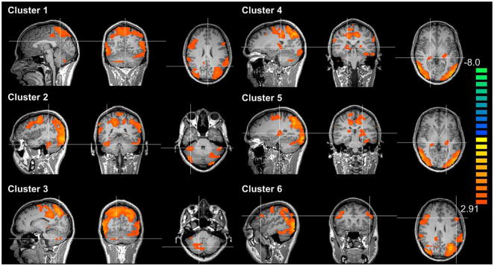
Orange shows how the brain lights up with Internet desire. Brain activity and desire for Internet video game play (Han et al., 2011)

The Body:
Dunckley (2015) notes that in addition to the effects of electronic screens on the eyes and brain are the effects on the child’s body. As a result of electronic screen interaction:
- Blood flows away from the organs like the gut
- Blood pressure increases
- Stress hormones are released

All these processes prepare the body for fight-or-flight. The research indicates that all forms of screen time create subtle changes in the cardiovascular system, which can cause significant damage over time. The fact that screen time is associated with what Dunckley (2015) calls metabolic syndrome is very concerning. Metabolic syndrome is a combination of the following:
- High blood pressure
- Midsection weight gain (spare tire)
- Abnormal cholesterol levels
- High fasting blood sugar

Metabolic syndrome is a serious condition that can promote:
- Diabetes
- Heart disease
- Stroke

Dunckley (2015) writes that up until recently, metabolic syndrome was rarely seen in children but is now sadly becoming increasingly commonplace. We are not clear on why it develops in some individuals but not in others. Nonetheless, it is believed to be connected in some way to chronic stress and poor sleep. More telling is the fact that the connection between metabolic syndrome and screen- time holds, regardless of level of activity,
which supports that screen time results in unhealthy physiological changes that surpass those changes due to low activity level (Dunckley, 2015).

Hyperarousal – Fight or Flight:

Dunckley (2015) notes that through the eyes, brain, and body, excessive consumption of media sends unnatural and overstimulating messages to the nervous system, which trigger and promote the fight-or-flight response and ensuing Electronic Screen Syndrome (ESS). It takes very little screen time in many children to get them all wound up because so many mechanisms can fire at once and then feed off one another. Each of these processes or mechanisms can, by itself, self-perpetuate the stress cycle, which, in turn, lowers the child’s ability to handle future stress (Dunckley, 2015). An aroused child will also have difficulty settling down to sleep. Sleep deprivation is associated with mental health problems, including depression, ADHD, anxiety, and mood disorders.

In a very bravely candid and enlightening interview cited in Kardaras (2016), Dr. Andrew Doan, who received his M.D. at Johns Hopkins and also earned a Ph.D. in neuroscience, described his own extreme media addiction and subsequent hyperarousal symptoms while he was in medical school over a decade and a half ago, “I had pain from my clicking finger all the way up to my forearm. And my cortisol levels were shot - through my hypothalamus-adrenal-pituitary axis (HPA), so I was getting fat because I had all of this cortisol floating around. I didn’t exercise, so I was retaining more body fat. And then finally my HPA axis was all dysregulated, so I was more prone to infection - I had pimples all over my face, I had stretch marks beginning. And then, finally, I got an infection in my armpit!

So, in addition to the carpel tunnel, I had this armpit infection that was streaking down my arm. And on top of that, because my blood pressure was going up because of the gaming adrenaline rush - my blood pressure was high, my cholesterol was high. And because my blood pressure was high, and I was sitting all of the time, I had hemorrhoids the size of walnuts. - I mean, literally! I was a young man - I was pissed off. Why do I have hemorrhoids like some pregnant women do? We’re talking about bloody, painful hemorrhoids…So I’m convinced that if people are addicted to this thing, it’s going to ruin their lives. It almost ruined mine - and it almost ruined my son and almost destroyed his confidence and his opportunities.” The reader is encouraged to read Dr. Doan’s excellent book, Hooked on Games, for more detail on the devastating impact that media addiction had on his life and how he overcame it.

Kardaras (2016) states that HPA dysregulation is correlated with depression, anxiety, psychotic breakdowns, and various mental disorders.

Dunckley (2015) describes how the following screen-related factors can contribute to fight-or-flight reactions as summarized below:

- Intense Sensory Stimulation: Bright screens, quick movements and supersaturated colors all feed into sensory overload. This intense stimulation heightens attention and arousal, which feed into fight-or-flight (Ivory et al., 2007). Dunckley (2015) notes that after the arousal, the brain experiences deprivation, which can be uncomfortable and lead to extreme irritability.

- Psychologically Engaging Content or Activity: The more engaging or enticing the activity or game is, the more dopamine-related activity and arousal are increased, which, in turn, reinforces itself over time, making it increasingly difficult to stop. Game developers are very aware of this and use violent, competitive, sexual, interesting, and/or shocking images and content to spike arousal for fight-or-flight responses (Ivory et al., 2007; Gentile, 2005). In terms of game type, role-playing, also known as MMORPG (Massively Multiplayer Online Role-Playing Games), are much more likely to promote addiction (Ng et al., 2005).

- Disruption of the Body Clock: When the brain is excessively exposed to unnatural bright light from electronic screens, the hormone melatonin, which serves as a sleep signal, is suppressed, and the ensuing natural biorhythms are disrupted (Higuchi, 2003). We know that the light from electronic screens is especially high in blue tones, which mimics daylight. These changes in biorhythms and the production of melatonin degrade the quality of sleep as the body does not enter the deeper phases of sleep as often or as long as needed. The research indicates that screen exposure results in delayed sleep onset and suppression of REM sleep, which is necessary for clearing the brain and solidification of learning (Cajochen et al., 2011). We know that if the brain does not have enough restorative sleep, it will not function well. Your muscles become excessively fatigued and you feel exhausted the next day – even if total sleep time is adequate. To compensate, the body then releases stress hormones such as adrenalin and cortisol as a means of keeping you awake, which helps to create a vicious cycle. Moreover, exposure to as little as 15 minutes close to bedtime can create these effects (Dunckley, 2015). In addition to disrupting the body clock, stimulating the body into a fight-or-flight mode will make it more difficult to sleep.

- Reward and Addiction Pathways: Brain scan studies have demonstrated that large amounts of dopamine are released when video games are played (Koepp et al., 1998), which is the primary chemical associated with reward pathways, as previously noted. Dunckley (2015) points out that this process can occur when there is no toxic substance, such as cocaine, and adds that compulsive video gaming and Internet use can be considered “arousal addiction” in that the user becomes addicted to high levels of stimulation and arousal and subsequently needs increasing levels of stimulation to attain or sustain that feeling. Tolerance then sets in as the reward pathways identical to those in chemical addictions become over-activated.

- Vividness, Screen Size, and Place: Not only is content an issue, but the research also shows that other factors, such as movement, pans, zooms, and how vivid/lifelike the images are, serve to trigger the orienting response and fuel repeated fight-or-flight responses (Datenbur et al., 2009).

- Media Multitasking: Multitasking is a misnomer, as discussed elsewhere in this paper, and is better described as multi-switching. We know that attempting to juggle more than one thing at a time puts additional cognitive load on the brain, which then, in turn, increases arousal and stress. It is typical for kids and teens to chat, text, watch TV, play video games, surf the internet, Skype, check email and/or do homework in various combinations. The research clearly shows that multitasking/multi-switching leads to physiological stress, impaired cognition, sensory overload, and negative mood (Mark, 2014; Becker, 2013).

- Radiation from Magnetic Fields (EMFs): Although somewhat controversial, it has been speculated that EMFs possibly are another source of hyperarousal and other stress responses, if not for all but for some people.
Hyperarousal
The Impact of Chronic Hyperarousal reported by Dunckley (2015) is summarized below:
- Blood Flow Shifts: When a person is under stress, blood flow to the brain is shunted away from the higher regions of the brain, i.e., the cortex, and directed to the more primitive parts of the brain, i.e., the limbic or old brain, to promote survival. As Dunckley (2105) notes, when addiction of any kind occurs in adolescence, there is a tendency to stunt the development of the frontal lobe, which, in particular, is responsible for decision-making, organization, planning, attention, impulse control, task completion, emotional regulation, and inhibition, among others. She posits that if screen time indeed induces a stress response and activates the addiction pathways, it very well could affect brain development in the long term by decreasing blood flow to the cortex and frontal lobe (Dunckley, 2015).

- Elevated Cortisol: As noted by Dunckley (2015), studies indicate that
- electronic screen activity impacts the regulation of cortisol (Wallenius, 2010). Although adrenaline is the primary hormone secreted in an acute stress reaction, cortisol is the dominant hormone released in chronic stress reactions. While cortisol helps protect and promote survival in the short term, elevated cortisol levels over longer periods of time actually become quite harmful. As noted earlier, chronically elevated cortisol is associated with obesity, diabetes, hormone imbalance, metabolic syndrome, and high blood pressure (Pervanidou et al., 2011). When we are under significant stress and when the body needs access to fuel, cortisol allows increased blood sugar to be available by counteracting insulin. This is not a problem in the short term, but if it continues for longer periods of time, it can promote weight gain specifically concentrated in the abdominal area and cause problems with insulin regulation. In addition, elevated cortisol dysregulates the production of other hormones to include the thyroid and reproductive hormones and over extended periods of time, excessive cortisol actually damages the brain (Nepomnaschy et al., 2004; Chrousos, 2012).

- Oxidative Stress: Dunckley (2015) states that chronic stress, be it electronically triggered or otherwise, is damaging to the very system that fights stress. On a molecular level, all cellular reactions in the body produce free radicals, and these free radicals are unstable as they have unpaired electrons that seek to grab another electron to become stable. When a particular cell is healthy, the free radicals are cleared out or scavenged by sufficient amounts of antioxidants, and appropriate balance is preserved. However, when the cell’s natural defenses are overwhelmed due to excessive stress, the antioxidants or scavengers are depleted, and oxidative stress or excessive free radicals develop. The free radicals and the unstable molecules that contain them build up and will then steal electrons from their own tissue. Proximal fats, proteins, and DNA is particularly vulnerable to being damaged. Over time, this progresses to cause inflammation, tissue damage, and poor efficiency, which leads to increasing degradation of the cell’s ability to deal with acute and prolonged stress. The brain is especially susceptible to oxidative stress. Oxidative stress can promote disruption of the blood-brain barrier, causing it to be more vulnerable to toxins. Second, oxidative stress degrades the myelin or fatty sheaths that insulate brain cells, promoting aberrant firing networks. (Dunckley, 2015).

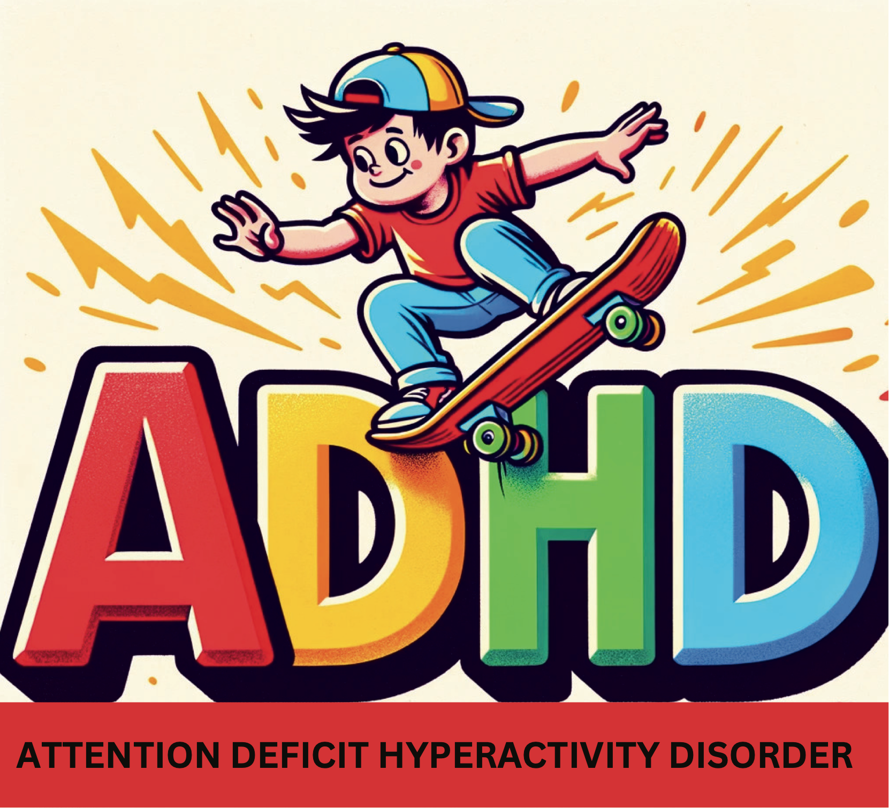
The ADHD Effect:
Kardaras (2016) notes ample research shows that exposure to video games and television in childhood and adolescence leads to significant risk for subsequent attention problems. In addition, he suggests that experiencing something exciting makes it increasingly difficult to downshift to something less exciting. He adds that it has been hypothesized that frequent exposure to screens may actually compromise a child’s ability to focus on specific tasks that are not as inherently attention-captivating, such as mundane tasks like schoolwork. Dr. Dimitri Christakis, cited in Kardaras (2016), writes, “I think that the concern is that the pacing of the program, whether it’s video games or TV, is overstimulating and contributes to attention problems.” In an earlier 2004 study, also cited in Kardaras (2016), Christakis found that the more TV a child watches between the ages of one and three, the greater the probability that they will develop attention problems by age seven. Moreover, this study determined that for each hour of TV consumption, the risk of attention problems increased by 10% over that of a child who didn’t watch TV. Dr. Christakis states, “When you condition the mind to become accustomed to high levels of input, there’s a chance that reality can be just too boring.”

Kardaras (2016) reports that brain-imaging research specifically shows that the prefrontal cortex, which, among other things, controls impulsivity, a big component of ADHD, is compromised by exposure to screens.

Kersting (2016) cites Dr. Elias Aboujaounde, the director of Stanford University’s Impulse Control Disorder Clinic, “The more we become used to just sound bites and tweets, the less patient we will become with more complex, more meaningful information. And I do think we might lose the ability to analyze things with any depth and nuance. Like any skill, if you don’t use it, you lose it” (Evangelista, 2009). Kersting (2016) notes that this technology use and brain neuroplasticity research led Dr. John Ratey, Clinical Professor of Psychiatry at Harvard School of Medicine, to coin the term acquired attention deficit disorder. Kersting (2016) suggests that it is possible that potentially thousands of children and teens are being misdiagnosed with disorders that they don’t in reality have and are being inappropriately prescribed powerful medications to treat them.

Pediatric Neurologist Dr. Martin Kutscher (2017) identifies three attentional networks in his excellent and research-based book Digital Kids:

- Stay-on-task network: This requires willful attention to a given task, and it is this network that allows us to actually execute a plan in a linear fashion. It is also called “top-down” attention, as it is voluntary and is evolutionarily placed in the “top” part of the brain and, as such, attempts to exert control over the lower parts of the brain.
- Sensory/emergency network: No matter what we are doing, our sensory network is constantly scanning our environment for safety and opportunity. Kutscher (2017) notes that these sensory detectors also pull us into multimedia and colorful video games. As a matter of safety, it is always switched on. Palladino (2015) notes that this system, which she terms the involuntary network, follows the strongest stimulus that captures it.
- Daydreaming network: This comes into play when the networks above are not actively dealing with a situation. During this time, the brain can ponder, think in a creative and non-linear fashion, consolidate previous learning, and restore itself. As Kutscher (2017) points out, “It is not only okay to be bored, but some boredom is essential for the brain to function well.”

Kutscher (2017) explains that the insula is believed to be involved in switching between these networks and that this switching takes energy and can result in fatigue and stress. Carr (2011), cited in Kutscher (2017), notes, “Many studies have shown that switching between just two tasks can add to our cognitive load, impeding our thinking and increasing the likelihood that we’ll overlook or misinterpret important information.” Kutscher (2017) points out that this is very important as it is part of the answer as to why a child can pay attention to video games but not do his homework. Specifically, the stay-on-task part of attention in video games is constantly bolstered by the sensory/emergency network, which is involuntary and effortless. On the other hand, writing an essay with paper and pencil does not share this effortless energy draw; instead, it relies mostly on voluntary and fatiguing effort.

Kutcher (2017) adds that, contrary to popular belief, our brain cannot multitask. A much more accurate term is multi-switching. He notes that engaging in digital distractions while attempting homework wreaks havoc on the attentional process. Depending on the study, research indicates that re-orientation to a task can take one to five minutes and, in some cases, as long as 25 minutes. Kersting (2016) cited a functional magnetic resonance imaging (fMRI) research study, which indicated that people who multi-switch use about twenty times more of their brain while engaging in simple multi-switching exercises. An unforeseen outcome of this research revealed that multi-switchers used the wrong part of their brain, the part known as the visual cortex. On the other hand, low multi-switchers needed only a small amount of “brain power” to complete the task, and they used the appropriate region of the brain for the task at hand, namely, the prefrontal cortex (Ophir, 2009).

Kutscher (2017) notes that the stay-on-task or voluntary attentional network – the ability to willfully control where to focus your attention and hence control your actions – is a very critical skill to master and is perhaps the most important predictor of future success. He cited the landmark marshmallow test conducted at Stanford University. Kids were offered a treat, such as a marshmallow, and told that they could eat it right away or if they waited alone for 15 minutes, they could have two instead. Most kids could only wait three minutes before eating up, and only 30% could last the full 15 minutes. Most interesting, follow-up studies on these kids up until age 40 showed that those children who could wait the distance did better on multiple aspects of life (Palladino, 2015,):

- Higher Scholastic Aptitude Test (SAT) scores
- More successful education
- Better success at keeping friends
- Greater financial success

It is fascinating that the scores on the marshmallow test were even more predictive than IQ. Thus, teaching our children self-control/voluntary attention is very crucial to future success.

Dunckley (2015) notes that children with attention problems generally have significant difficulty sustaining and shifting attention, as well as initiating and completing goal-oriented activities, especially when the task is tedious or difficult. In addition, there are difficulties in executive function, which include:

- Planning
- Organizing
- Revising
- Strategizing
- Attending to details
- Managing time and space
- Inhibition of negative behaviors (putting on the brakes)

Dunckley (2015) notes that difficulties with attention and executive functioning profoundly impact the quality of life from academics to career to success in personal relationships. She shares that attention and executive functioning are very much dependent on dopamine and another neurotransmitter, norepinephrine, and that it is these two chemicals that ADHD medications seek to increase. Dunckley (2015) states that Electronic Screen Syndrome (ESS) can look exactly like ADD and will most definitely exacerbate ADD if it preexists.

Turner (2017) notes that symptoms of ADHD can be environmentally induced. He cited a 2015 Microsoft report that recognized a decline in attention span due to our interaction with our digital environment. Turner reported that this report was removed from the Internet, but beforehand, publications had covered it. “A recent study from the Microsoft Corporation has found that this digital lifestyle has made it difficult for us to stay focused, with the human attention span shortening from 12 seconds to eight seconds in more than a decade. If that doesn’t scare you, a goldfish reportedly has an attention span of nine seconds” (Turner, 2017).

Excessive gaming in adults is linked to sleep deprivation, which, in turn, is associated with symptoms similar to ADHD. We clinically observed a strong correlation between the number of hours spent gaming and the severity of ADHD-like symptoms (Eickhoff et al., 2015). Importantly, these symptoms showed significant resolution following periods of adequate sleep.

Cyber void is so full of amazing emptiness
that makes us feel fulfilled.
- Munia Khan
Depression:
Turner (2017) eloquently writes of his own struggle with depression secondary to media overconsumption, “My relationship with the Internet was not alleviating feelings of loneliness; it was amplifying my loneliness, bringing me to a state of frustrated depression. I felt boxed in, unable to breathe, trapped in an inescapable thought bubble of my own f*ed up, addictive desires. I conditioned myself to need constant stimulation. I couldn’t read, talk, study, or play the piano – all things that I love – because it all seemed too slow, too one-note…I was always tired, yet always racing in a mad frenzy. I couldn’t focus. I was anxious. I was unable to engage in solitude. My thoughts were a jumble. “

On a surface level, we are the most connected society that has ever walked the planet. Each second, we send over 7,500 tweets, 1,394 Instagram photos, and over two million emails and view over 119,000 YouTube videos (Internet Live Stats, website, www.internetlivestats.com). Americans send 69,000 texts a second, translating to over six billion texts in the US daily. Paradoxically, the more connected we think we are with the façade of the Internet, the more disconnected and depressed we actually become. As Johann Hari (2015) said in a Ted Talk, “We are the most disconnected society that has ever been, surely.” Dr. Jean Twenge, a San Diego State University professor and the author of her compelling book Generation Me, analyzed the data from approximately six million teens and adults in the US and concluded that self-reported depression has increased markedly since the 1980s. She found that teens, in particular, are 74 percent more likely to exhibit difficulty sleeping and are twice more likely to seek help from a mental health professional (Twenge, 2014). Farchian (2016) reported that people are ten times more likely to suffer from depression today than in post-WWII, with women and teenage girls more than doubly prone to depression than men.
A 2018 study conducted by Blue Cross and Blue Shield revealed that the highest rate of growth in depression has occurred in the youngest and the most digitally connected age bracket (see chart below). “The most dramatic rise in major depression diagnosis is among those under 35 years of age. Between 2013 and 2016, diagnoses increased 63 percent among adolescents and 47 percent among millennials. Gender differences among millennials were similar, but there was a 65 percent increase for girls compared to 47 percent for boys among adolescents” (Blue Cross and Blue Shield, 2018).

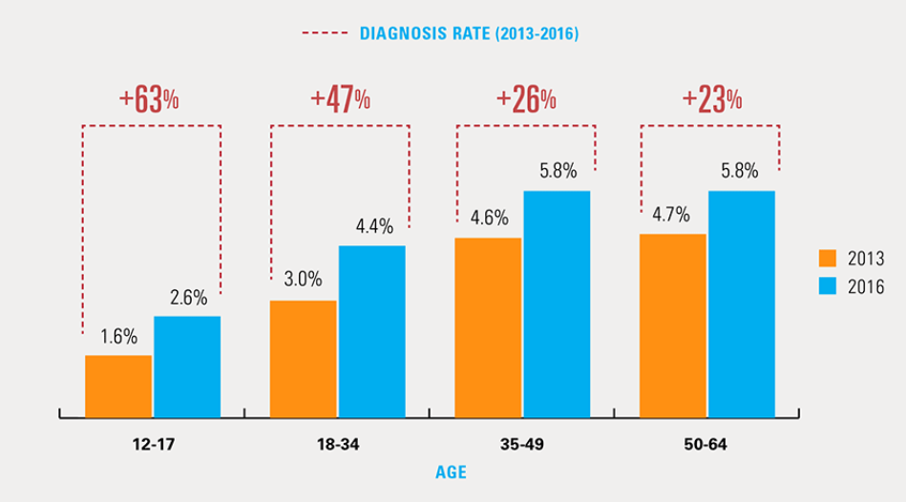

The CDC recently reported that the suicide rate among the “Most Digitally Connected Generations” has increased at an alarming rate in the last 10 years after being flat for nine years. This 30% increase in suicide correlates with the advent of the smart phone (see graph below).

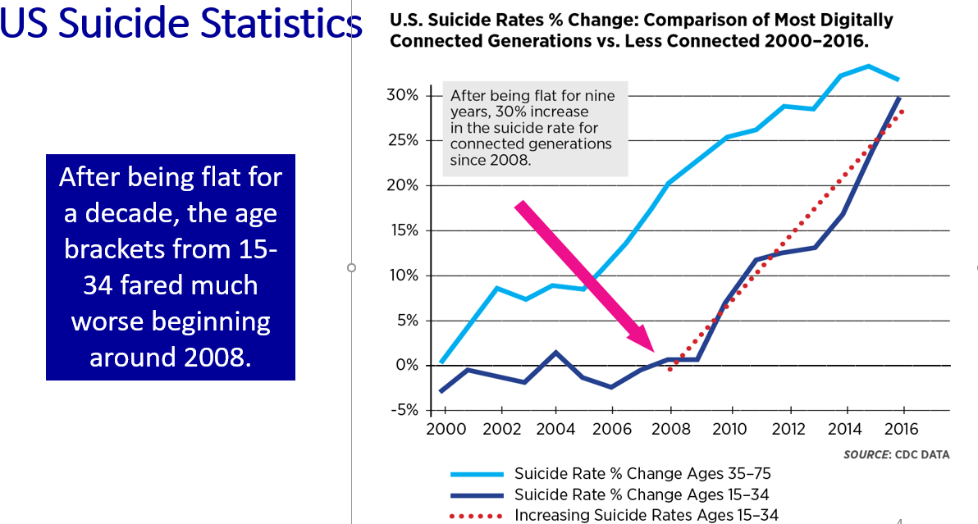

Shared with permission – Peter Ryan, CAPT, USN (R)

Kardaras (2016) cites the following concerning statistics:

- A 1998 study at Carnegie Mellon University found that Web use over a two-year period was correlated with increased depression, feelings of loneliness, and a loss of “real-world” friends.
- A 2012 Missouri State University study of 216 students revealed that 30 percent of Internet users showed signs of depression and that the depressed kids were more intense Web users.
- A 2014 study looked at 2,293 seventh graders and found that Internet addiction led to increased depression, hostility, and anxiety.
- A 2014 study conducted in Pakistan with 300 graduate students found a positive correlation between Internet addiction and depression and anxiety.
- A 2006 Korean study involving 1,573 high school students found a correlation with Internet addiction, depression, and thoughts of suicide.

Recently, the term Facebook Depression has emerged – namely, the more “friends” one has on Facebook, the higher the likelihood of depressive symptoms (Kardaras, 2016). Kardaras (2016) notes this is a double whammy in that the more time spent on social media and the more texting an individual engages in, the higher the probability of both depression and media addiction, which, in turn, only increases a sense of isolation and disconnection from healthy living. Kardaras (2016) cites a Case Western Reserve University School of Medicine study that “hypernetworkers” were prone toward (Pederson, 2015):

- Higher rates of depression
- Increase substance abuse
- Poor sleep
- Greater reported stress
- Poor academic performance
- Higher rates of suicide
- 69 percent more likely to have sex
- 60 percent more likely to report four or more sexual partners
- 84 percent more likely to have used illegal drugs
- 94 percent more likely to have been in a physical fight

Psychosis:
As reported in The Guardian (2011), "’Gamers can't tell real-world from fantasy,’ screamed the headline in the Metro on Wednesday morning. Dr. Mark Griffiths, who heads up Nottingham Trent University's International Gaming Research Unit, must have slumped back in his chair with incredulous horror when he read that.

His team had been carrying out another video game study when they discovered that many of their 42 interviewees were talking about a similar experience. Often, after playing a game for a long time, they would momentarily transfer elements of the game content, or the interface, into their real lives, usually harmlessly.

Griffiths knew it was a common phenomenon – he'd experienced it himself playing Tetris – but it hadn't been named or categorized. So, the department came up with a term – Game Transfer Phenomenon – and started looking into it. The resulting report has just been published in the International Journal of Cyber Behaviour, Psychology and Learning.”

Kardaras (2016) writes that hyperarousing digital imagery of interactive screens creates more of an invasive and intrusive mental assault on our psyches than books and TV. He cites one video gamer, “I was freaked out when I went outside, and trees were round and not square like the videogame” – or of being totally consumed with and obsessed about the game: “I cannot stop thinking about Minecraft. It’s ruining my life.” He adds that Professor Mark Griffiths and Dr. Angelica Ortiz de Gortari’s research reveals that some gamers cannot stop thinking about games while others confuse the video game with real life. Specifically, video game playing can induce pseudo-hallucinatory-like experiences.

A few, among many examples, of game-induced psychotic behavior:

- In 2007, a Chinese boy poured gasoline on another gamer and lit him on fire. He later stated that he had “lost himself in World of Warcraft” and believed that he had become a “fire mage” (Kardaras, 2016).

- In December 27, 2004, after playing World of Warcraft for 36 hours straight, a 13-year-old Chinese boy jumped to his death after leaving a note that he wanted to join his heroes (Kardaras, 2016).

Dunckley (2015) suggests that dopamine dysregulation might be, in part, the underlying mechanism for screen-related psychosis. She notes that drugs and medications that increase dopamine, such as stimulants, are very capable of producing psychosis and, on the other hand, many of the medications used to treat psychosis block dopamine. As you will recall, gaming releases dopamine. She adds that other implicating factors could include sensory overload and the brain’s inherent inability to discern a virtual environment from a real one, especially as games become increasingly vivid and lifelike.
Violent Behavior:
Kutcher (2017) notes that there is strong and compelling evidence that playing violent video games (which represent at least 60 percent of video game sales) leads to aggressive behavior in children and adolescents. He cites a very intensive meta-analysis of 381 studies on over 130,000 participants, which supported that violent video games significantly increased aggressive cognition, aggressive behavior, and physical arousal. At the same time, they decreased sensitivity to violence and social interaction. Greenfield, 2015).

In another exhaustive summary of years’ worth of research cited in Kardaras (2016), Dr. Craig Anderson from Iowa State University summarized 130 research studies with more than 130,000 participants and, likewise, concluded that exposure to violent video games makes for more aggressive and less caring kids – regardless of age, sex, or culture. Dr. Anderson concluded, “We can now say with utmost confidence that regardless of research method - that is, experimental, correlational, or longitudinal - and rirrespective of the cultures included in this study (East and West), you get the same effects. And the effects are that exposure to violent video games increases the likelihood of aggressive behavior in either short-term or long-term contexts (Anderson et al., 2010).

Greenfield (2015) notes that gaming is associated with less activity from a region in the brain that is involved in emotionally charged memory, namely, the amygdala. Dunckley (2015) notes that one of the reasons for the increase in aggressive behavior secondary to violent gaming is due to the blunting of our mental and physiological aversion to violence, be it real or virtual. She adds that studies of violent video games have clearly documented desensitization by measuring brain, cardiovascular, skin, and empathy responses (Engelhardt, C. et al., 2011; Bartholow et al., 2006).

Brain imaging research at the Indiana School of Medicine (2011) revealed a direct relationship between playing violent video games and quantifiable brain changes involving “less activation in certain frontal brain regions (regions that control aggression, self-control, and emotion) following one week of playing violent video games. This led researcher Dr. Wang to conclude, “These findings indicate that violent video game play has long-term effects on brain functions. These effects may translate into behavioral changes over longer periods of gameplay.”

As Kardaras (2016) notes, “People with compromised frontal brain regions tend to be much more impulsive and potentially aggressive; this, in turn, helps us to understand what those aggression studies were showing from a neurological perspective.” Not only does aggression get worse in the short term, but prolonged exposure over many years only adds salt to the wound.

As noted by Kardaras (2016), the most horrific example of this issue is the Sandy Hook Elementary School mass shooting involving the infamous 20-year-old Adam Lanza on December 14, 2012, in Newtown, Connecticut, who fatally shot 20 innocent children between the ages of six and seven and six adult staff members. It has been estimated that by the time Lanza was 17, he had racked up 83,000 online kills and 22,000 head shots. He had been obsessed with “World of Warcraft, Combat Arms, Call of Duty, and Modern Warfare 2,” multiplayer first-person shooter games. In Modern Warfare 2, Lanza became an undercover CIA agent who joined a group of Russian terrorists at an airport with the aim of killing unarmed civilians, including women and children. Finally, according to the Connecticut attorney general’s report, Lanza had a little-known game called “School Shooter” on his hard drive, and in that game, the shooter goes from classroom to classroom, killing children and teachers before committing suicide, which sadly mirrors what Adam Lanza ultimately did. Although this young man was clearly mentally disturbed in a profound way, even without video gaming, one can only speculate that violent video gaming only added to the already burning fire in his twisted and psychopathic mind.

Look, the brain of a child is shaped by the interactions they have with their parents – that’s just absolutely clear. We need to be in the physical and relational world before we reduce it down to screens.
- Dan Siegel
Child Psychiatrist and Author

In a clinical observation, a young man’s extensive engagement in violent video games contributed to extreme sleep deprivation and provoked homicidal ideations, including vivid dreams of violence mirroring gameplay (Eickhoff, 2015). This individual, gaming for 50-60 hours and working over 40 hours weekly, averaged under four hours of sleep nightly, leading to mental function deterioration and mood issues. Treatment, which cut off access to games and devices, initially caused intense withdrawal but ultimately improved sleep to 7-8 hours nightly without medication. The restoration of regular sleep patterns was crucial in diminishing violent thoughts, homicidal ideations and enhancing mental clarity, highlighting sleep deprivation's potential role in exacerbating violent tendencies and shootings in gamers.

Emotional/Social Development:
We know that children need lots and lots of the following to develop optimally (Dunckley 2015):

- Several hours of unstructured play each day to appropriately stimulate and integrate sensory pathways
- Secure attachment and bonding to caregivers
- Lots of touch
- Varying levels of environmental stimulation, which support calm alertness during the day and good sleep at night
- Conversations with adults
- Contact with nature
- Creative outlets, such as dance, music, and art

Children who spend excessive amounts of time with their faces planted in front of screens have less time experiencing and absorbing these things. In addition, excessive screen time overstimulates the visual and auditory systems, making it difficult to filter relevant from non-relevant stimuli. Dunckley (2015) adds that since long-term brain development is impacted by neglect more than any other factor, that any lessening of bonding time is reason for concern (Strathearn, 2011). It has been shown that reductions in deep touch can cause children to be restless and seek out deep sensory input, including hitting, squeezing, and pushing (Dunckley, 2015).

Kersting (2016) defines Emotional Intelligence (EQ) as the ability to use, understand, and manage our emotions in a positive, healthy, and productive way and notes that EQ helps us communicate effectively, empathize with others, and conquer the many challenges in life. Studies have revealed that EQ is, in fact, twice as important to superior leadership than IQ.

Goleman (2016) developed a “mixed model” for emotional intelligence with five main dimensions:

- Self-Awareness: The ability to know your own feelings. This means you are aware of your emotional triggers and have an ability to deal with them.
- Self-Management: This involves the ability to keep your emotions in check when they start to ramp up and become problematic or disruptive.
- Motivation: Most people are motivated by external/outside events such as money. Emotionally intelligent people are more internally/intrinsically motivated (i.e., internal peace or a sense of pride for doing the right thing).
- Empathy: Empathy involves the ability to appreciate and support the feelings of someone else by responding appropriately to their situation and feelings. This will often lead the person to suspend the needs/feelings of oneself in support of the needs/feelings of another.
- Social Skills: This involves, among other things, the ability to deal with others in that you can find a common ground with other people. It involves the ability to negotiate, problem-solve, and compromise.
The evidence is mounting that excessive media consumption negatively impacts social/emotional development. Kersting (2016) points out that kids are much more emotionally fragile than they used to be. Peter Gray, a research professor at Boston College, writes that faculty across the country have reported that today’s students are much more emotionally fragile and lack resilience. Students have more emotional crises and seek help for typically minor problems with basic life. He noted, for example, that one college student sought professional counseling for being called a “bitch” and another because she saw a mouse in her apartment (Gray, 2015).

Gray (2015) noted the following trends in college students:

- Students are needier and less resilient.
- Students are increasingly afraid to fail, and they do not take risks. Failure is perceived as catastrophic and totally unacceptable.
- Faculty, especially younger ones, feel extreme pressure to give into student wishes in fear of getting low ratings from students.
- Students email faculty about increasingly trivial matters and become demanding about wanting prompt replies.

Kersting (2016) speculates that students who spend hours and hours on social media and technology are conditioned, at least in part, to “live” into the trends mentioned above. He adds that the same area of the brain affected by multitasking is also responsible for managing emotions. According to Nash (2013), “A strong emotional intelligence equals a healthy cerebral cortex, the frontal part of the brain that is responsible for executive functions.” When a message comes to the brain, it first goes to the emotional center of the brain, the amygdala. An efficient brain will then send that particular message to the cerebral cortex, which subsequently decides what should be done with the information at hand. People with poor or low emotional intelligence tend to have a weak connection between the emotional part of the brain, the amygdala, and the thinking part of the brain, the cerebral cortex (Kersting, 2016).

In her most recent book, iGen: Why Today’s Super-Connected Kids Are Growing Up Less Rebellious, More Tolerant, Less Happy – and Completely Unprepared for Adulthood, Twenge (2017) analyzed four large, nationally representative studies of over 11 million Americans since the 1960s and identified several important trends among children who have only known life with the internet, which she calls i’Gen’ers. Specifically, I’Gen’ers:

- Are more insecure
- Evidence a significant decline in person-to-person interaction
- Are obsessed with safety
- Are insecure about income and their ability to make it in the world
- Tend to extend their childhood
- Are ill-prepared for adulthood
- Are less happy
- Are more tolerant and less rebellious

Kersting (2016) points out that EQ is not something we are born with and can only be learned by observing voices, body posture/language, and/or facial expressions. You must have direct face-to-face 3D interaction or connection with other people as opposed to 2D face-to-screen interaction. Nass (2013) writes that this learning starts in infancy and is not an easy thing to acquire. It was much easier for previous generations to build a strong EQ because they had so much more face-to-face interaction. If a child is spending hours and hours of the day in electronic distraction, they are not only dysregulating the brain, but they are also not getting sufficient daily exposure to develop the neuropathway substrate for effective social development.

Brain imaging studies indeed indicate that gaming addiction damages the insula, an area of the brain specifically involved in empathy (Weng et al., 2012; Suzuki, 2012). Empathy is the ability to resonate with another person’s state of mind and actually feel what they are feeling.

Dunckley (2015) notes that the more a child spends behind a screen, the more socially anxious or inept they become, creating a self-perpetuating spiral in socially anxious children, in particular. She adds that in past generations, the strong desire to belong to a social group during adolescence tended to override resistance to social interactions, which would decrease over time as a result of practice. Sadly, the trend today is not to push socially anxious children and teens to practice face-to-face interaction as much as in the past, as much of their social needs can seemingly be met online. Over time, then, many of these children get worse. They cannot make eye contact as they find it aversive, they cannot hold a conversation, they cannot read nonverbal cues, they shake hands like a “dead fish,” they act much younger than their chronological age, they fear talking on the phone, they cannot maintain a topic of conversation for any length of time, they lack empathy, they are unable to initiate connection with another, they cannot talk about matters outside of their own interests, and their facial expressions are off-the-mark if not outright bizarre. As such, many of them face a questionable future at best.

For families with an autistic child who has been consuming considerable amounts of media, please be kind to yourself and do not place unfair blame because you did not have the information. Consider the next section as an opportunity to help your child as you reconsider their media use and its possible impact on their autism. Virtual autism is a term used to denote autism-like symptoms in children primarily caused by excessive exposure to screens from devices such as televisions, computers, tablets, or smartphones, especially at a very young age, typically under three years old (Harlé, 2019; Christakis, 2020; Heffler et al., 2020). The concept emerged from observations that children displaying autistic behaviors tended to have a history of intensive screen exposure and that some of these behaviors seemed to abate when screen time was reduced or eliminated. We have seen young children with severe autistic symptoms drop their autism diagnosis after six months of zero screen time. Children born with autism show improvement, too, because without screens, their developmental trajectory changes for the better.

We see a similar neurological phenomenon in the brain areas that control vision called the visual cortex. In babies, when there is a visual obstruction in one or both eyes, the visual signals to the visual cortex are disrupted. If left untreated, the child loses vision daily because the visual cortex at the back of the brain atrophies. The vision loss will become permanent if left untreated. This is known in the field of ophthalmology as amblyopia. To treat amblyopia, the ophthalmologist corrects the problem causing the visual obstruction and patches the better-seeing eye for six or more hours daily. We can clinically observe the worse seeing, amblyopic, eye improve vision monthly. If treated early, then we can see normal vision in six to twelve months.

Virtual autism is similar. Digital media is holding the child’s attention at the cost of redirecting neurological development away from the brain areas associated with speech, eye contact, emotional regulation, social communication, creativity, and numerous other skills. On the other hand, the child over-develops skills learned from the videos watched or games played. With years and years of using digital media for six, eight, or ten hours daily, the brain strengthens the brain centers associated with the processing of the media being consumed. The child may display autistic symptoms, sometimes severely.

Autism rates were about 1 in 5000 children in the 1970s. In 2023, the CDC stated that 1 in 36 children have autism. While some of the increased rates can be attributable to better recognition and diagnosis, the missing intervention is the removal of the excessive utilization of digital media. If you have a young child with autism or a grandchild with autism, then there is hope. To re-emphasize our previous statement, we have seen young children with severe autistic symptoms drop their autism diagnosis after six months of zero screen time. Children born with autism show improvement, too, because without screens, their developmental trajectory changes for the better.

Let’s consider the case of the twin sisters who were about age six. One girl used her digital tablet for numerous hours daily. The other girl was not interested in digital media. The girl who used her digital tablet excessively was developing autistic symptoms. The mother was encouraged to cut back significantly or remove the digital tablet completely. Within six months, the girl who was behind developmentally caught up to her sister and was no longer considered to be on the autistic spectrum.

Around 2012, I (Dr. Doan) gave a talk on digital media and brain development. One of the parents in the audience had a severely autistic boy who was about age 10. The family decided to remove all screen time from their son, who would have a temper tantrum and require being bear-hugged for an hour after his tablet was removed. This family continued to remove all digital media from their son’s life. I saw the parents nine years later, and they proudly informed me that their son is now a highly functioning autistic man and that he graduated from high school. People cannot tell their son has autism. This couple is certain that removing all digital media from their son’s life changed his developmental trajectory and changed his life.

These stories are not isolated incidences. We have communicated with doctors, early intervention therapists, and professionals around the world who have observed similar results with the removal of excessive digital media (Harlé, 2019). Digital media is a convenient babysitter for young children, but the neurological costs are devastating.

The brain is neuroplastic and can change, but less so as we age. The brain is fully formed and mature by age 25. Therefore, the earlier the removal of excessive digital media consumption, the more impact it will have on brain development. The later the intervention, the less impact it will have.

Every adversity, every failure, every heartache carries with it the seed of an equal or greater benefit.
- Napoleon Hill

Part Five – A Few Positives
T
o be fair, there are some benefits from technology use, as nicely summarized by Dr. Philip Zimbardo in his excellent book, Man Interrupted (Zimbardo, 2016):
- Players in MMORPG (Massively multiplayer online role-playing games) can develop reputations, allow theming to build trust with players, which is oftentimes difficult for them to acquire in the “real world.”
- Positive gaming can also take the form of learning and/or training programs, which can have “real world” impacts – for example:
- Jane McGonigial’s World without Oil – helped people become engaged in promoting real changes in people’s attitudes about possible oil crises
- The game Foldit is a protein designing game, which has helped scientists solve problems related to HIV that had puzzled them for years.
- Xbox and Nintendo Wii encourage and promote exercise in certain programs.
- Directing attention toward a virtual world can be a very good thing – even therapeutic. For example, researchers at the University of Washington and Loyola University have found that burn patients who played video games were often distracted from and experienced less pain than when they were not distracted. In fact, MRI studies confirmed that being in a virtual world actually decreased the amount of pain-related activity in the brain.
- It has been suggested that fluid intelligence can improve with gaming. For example, the military has reported that soldiers who are gamers score 10 to 20 percent higher in perceptual and cognitive ability (Freeman, 2015, cited in Zimbardo, 2016).
- Surgeons who play video games for at least three hours per week have been shown to make fewer surgical errors in more advanced surgeries and perform faster than the control group (Dobnik, 2004, cited in Zimbardo, 2016).
- Young men who play single-player video games in moderation (between once a month and most days a week but not every day) have been shown to perform better in math, reading, science, and problem-solving compared to students who never or almost never play; however, those who play collaborative online games do worse that those who don’t play at all (ABC of Gender Equality in Education, cited in Zimbardo, 2016).
- Video games reduce pain in clinical settings, such as burn treatments, childbirth, and surgical procedures (Hoffman et al., 2001). Video games can literally be a digital drug (Gilman et al., 2015).
The opposite of addiction is not sobriety; the opposite of addiction is connection.
-Johann Hari

Part Six - Treatment - How do we Fix this and Save our Children?
T
here are four essential components to the treatment of media addiction:
- Connection to Healthy Living
- Detox
- Rules for reintegration of media - Media contract
- Safety guards/monitoring and support

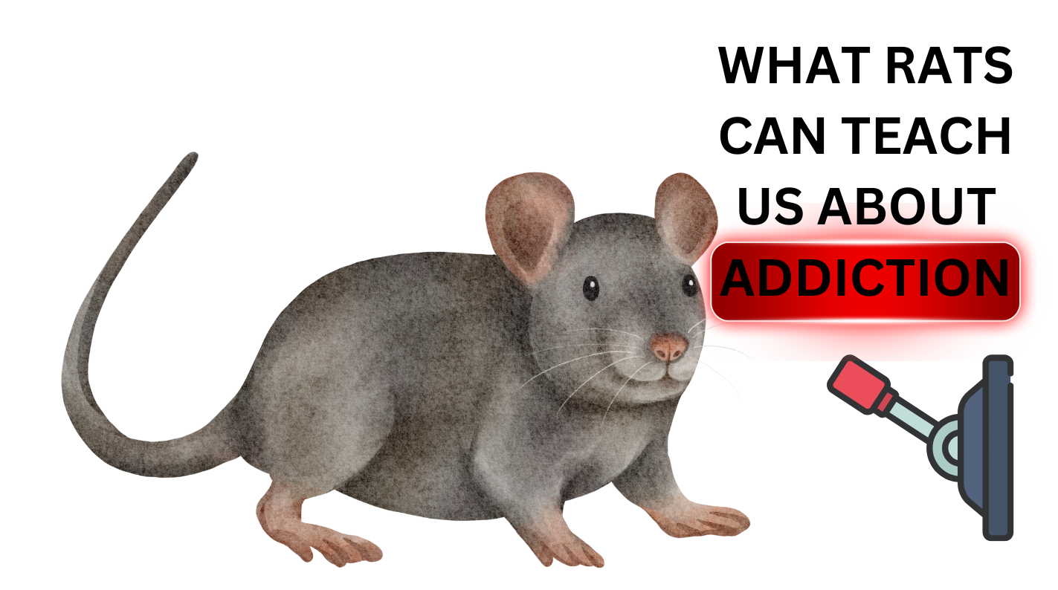

Treatment - Connection to Healthy Living:
In the 1960’s, well-known psychologist B.F. Skinner conducted a series of studies involving rats in what became known as Skinner Boxes. In these experiments, the rats were frequently starved and isolated and could get tiny pellets of food as long as they pushed a little lever on the inside of the Skinner Box over and over. In ensuing addiction studies, these rats would be tethered to the box’s ceiling with a surgically implanted needle, which extended to the rats’ jugular vein, and each time the rats pushed the lever, they would get a small morphine drip into their brain. The result of these rather barbaric and cruel studies was that the rats became hopelessly addicted, which led Skinner and his colleagues to conclude that the power of the addiction was solely in the drug itself.

A decade later, a Canadian researcher, Dr. Bruce Alexander, became very skeptical of this research, given that not all people who take a drug will become addicted to it. Being aware that rats in their natural habitat, like people, are powerfully social, Alexander wondered if the Skinner experiments merely indicated that isolated rats are more likely to become addicted than non-isolated rats. With this premise in mind, Alexander and his research team developed an experiment with two groups of rats, each having free access to drug water, with one group being kept in isolation, similar to the Skinner Box experiments and the other group consisting of several rats together in large open areas filled with fun things that rats love, such as loads of food, platforms for climbing, running wheels, and tin cans to hide in. Happily, for the second group, it was co-ed, and the rats were free to have sex, which they apparently enjoyed similar to humans. The second group setting eventually became affectionately known as the Rat Park. The results were stunning; the isolated rats in the Skinner Boxes became total addicts and the rats in the open and enjoyable spaces of the Rat Park never became addicted, in fact, most of them never even touched the morphine water at all. Alexander eventually concluded that addiction was less about the pull of the drug and more about the condition of the life of the rat; specifically, without connection and socialization, a rat is more susceptible to addiction. Moreover, he surmised, “People do not have to be put into cages to become addicted – but is there a sense in which people who become addicted actually feel ‘caged?’. The view from Rat Park is that today’s flood of addiction occurs because our hyperindividualistic, hypercompetitive, frantic, crisis-ridden society makes most people feel socially and culturally isolated…They find temporary relief in addiction to drugs or any of a thousand other habits (such as media – emphasis mine) and pursuits because addiction allows them to escape from their feelings, deaden their senses, and experience an addictive lifestyle as a substitute for a full life” (Alexander, 2010). Alexander later adds, “Addiction is not about your chemical hooks, it is about your cage, it is an adaptation to your environment.”
The Rat Park
Hari (2015) in a TED talk on addiction in which he described a new way of looking at addiction that emphasizes the value of connection with references to the Rat Park research stated, “I’ve been talking about how disconnection is the major driver of addiction, and it’s weird to say (addiction has) grown because we’re the most disconnected society that’s ever been, surely.” He adds, “Addiction is about bonding. If you can’t do it with people, you will do it with a substance. Now that might be gambling, that might be media, that might be cocaine, that might be cannabis; you will bond to something because that is our nature. That’s what we want as human beings.”
Kardaras (2016) posits (and I totally agree) that according to this perspective, today’s epidemic of media overconsumption is less about screens and much more a function of the unhealthy society in which our children are growing up. This being the case, it has substantial implications for treatment. “Unplugging” our children is not sufficient in and of itself. Rather, children need to be then “plugged into” alternatives. In short, we have to “connect” them to a meaningful and fulfilled life and lifestyle.
So, as we look toward solutions to controlling our children’s media consumption, we must have a template for what healthy living looks like. One of the most influential books I have found to address this issue is the groundbreaking book Lost Connections by Johann Hari (2018). In this book, award-winning journalist and critical thinker Johann Hari, who’d suffered from depression since he was a child, set out on a three-year journey around the world to seek answers to his own depression. He talked with psychiatrists, epidemiologists, neurologists, neuroscientists, social scientists, and many other disciplines around the globe, and also explored different cultures and how they fared with these issues. In addition, he conducted a comprehensive review of the literature. He concluded that much of what we have been led to believe about the genesis and treatment of depression and anxiety is totally wrong. He determined that in many, if not most cases, depression and anxiety are the result of crucial and growing problems with the way we are living our lives. He discovered that there are nine underlying causes of this problem, which are summarized as follows (Hari, 2018):
Cause One - Disconnection from Meaningful Work:
For children and teens, meaningful work involves school, responsibilities in the home, and possibly a part-time job. Hari (2018) noted that the polling company Gallup conducted the most comprehensive study to date on work satisfaction/dissatisfaction between 2011 and 2012 to determine how people across the world felt about their work. Of the millions of workers across 142 countries, Gallop determined that only 13 percent reported being “engaged” with their work (Davies, 2016). On the other hand, 63 percent were “not engaged” - meaning no passion for one’s work. Finally, 24 percent were “actively disengaged” - which translates to acting out their unhappiness. In sum, twice as many people hate their jobs as love their jobs. To better understand the high rates of depression and suicide in civil servants, investigators determined that a lack of control and little connection between effort and reward were highly predictive (Marmot et al., 2002).

The above study suggests that as we wean our children from excessive media use, we need to help them develop a sense of empowerment, purpose, and accomplishment in what they do. So, allow them to choose between chores when appropriate and ensure they receive positive feedback for a job well done (this does not always have to be monetary). Far too often, parents are placating their children, doing their homework for them, and not allowing them to enjoy pride in a well-accomplished job (Marmot et al., 2002).

Cause Two – Disconnection from Meaningful People:
Dr. John Cacioppo (2006, 2008, 1010), a neuroscience researcher, studied the impact that loneliness has on health. He and his colleagues determined that loneliness causes cortisol levels to go through the roof – as much as that caused by some of the most disturbing things that can ever happen in your life. As Hari (2018) summarizes Cacioppo’s research, “Becoming acutely lonely, the experiment(s) found, was as stressful as experiencing a physical attack.” Another researcher, Lisa Bergman, followed both isolated and highly connected people over nine years and found that isolated people were two to three times more likely to die during lonely periods and that, specifically, almost everything during lonely periods becomes more fatal for lonely people to include heart disease, cancer, and respiratory problems (Pinker, 2015). In short, loneliness can be deadly (Monbiot, 2014). In addition, research conducted by Cacioppo et al. (2010) conducted a five-year longitudinal study, which showed that loneliness is not merely the result of depression but indeed leads to depression as well. In this study, he found that on a measure of 0 percent loneliness to 100 percent loneliness moving from 50 percent lonely to just 65 percent lonely increases your chances of becoming depressed by eight times. He concluded that loneliness causes a significant amount of depression and anxiety in our society. In a Ted Talk presentation, Cacioppo (2013) reported a rather shocking meta-analysis study of over 100,000 participants, which found increased risks of dying early due to the following:
A
ir pollution: 5% increased risk of dying early

O
besity: 20% risk of dying early

A
lcoholism: 30% risk of dying early

L
oneliness: 45% risk of dying early

A 2018 study conducted by Cigna (see diagram below) revealed that compared to older generations, the youngest is the loneliest generation ever (Cigna, 2018).
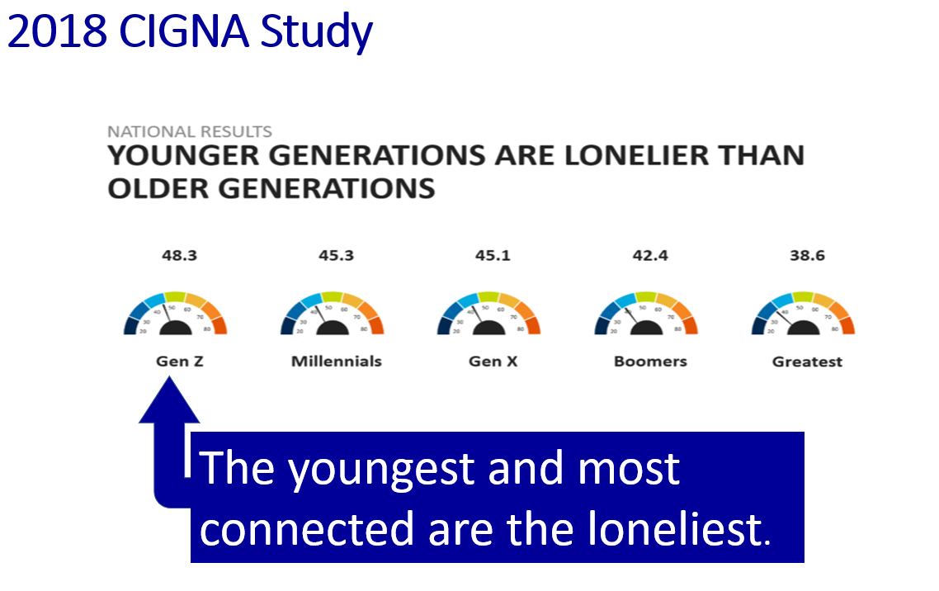
The implications of this research are clear; specifically, it is our job to ensure that our children are not isolating themselves excessively but are instead encouraged to connect in positive peer relationships as well as in positive family relationships. This should not be optional – get them out of their bat cave.
Cause Three – Disconnection from Meaningful Values:
Hari (2018) notes that an American psychologist Tim Kasser, has spent much of his professional career investigating the impact of values on our emotional and physical health. He specifically researched what philosophers had been suggesting for thousands of years - that if you overvalue money and possessions or think about life mainly in terms of how you look to other people, you will be unhappy (Belk, 1983). Kasser’s research specifically determined that the more materialistic you are, the more likely you are to score higher on measures of depression. In his studies, materialistic people had a tougher time with life in general. They tended to be sicker and angrier. “Something about a strong desire for materialistic pursuits,” Kasser wrote, “actually affected the participants’ day-to-day lives” (Kasser, 2002). Hari (2018) notes that materialistic values, which tell us to spend our way to happiness, look like real values, yet they don’t give us what we need from values, namely, a path toward a satisfying and fulfilled life and instead, fill us with “psychological toxins,” which can distort our minds.
In my family therapy sessions with media-addicted kids, I ask parents to define, evaluate, and clarify their family values and additionally determine what their family name stands for. In addition, I sometimes give them the assignment of developing a family Coat of Arms. Sadly, there is far too little discussion about family and personal values these days. Good values are like a compass that helps keep us on a “true north” path toward healthy living.

Cause Four – Disconnection from Childhood Trauma:
In the mid-1980s, Dr. Vincent Felitti was commissioned by Kaiser Permanente to explore the issues of obesity, as nothing this hospital group was doing helped put a dent in improving this epidemic. His research led him to explore the impact of what he called the Adverse Childhood Experiences (ACE) Study (Felitti et al., 2014). In this study, people were asked about ten different categories of horrible things that happened to them when they were children to include abuse, neglect, etc. The results indicated that for every category of traumatic experience you had as a child, you were dramatically more likely to be depressed as an adult. If you had six categories of traumatic events, you were five times more likely to become depressed, and if you had seven categories, you were an astounding 3,100 percent more likely to commit suicide as an adult (Felitti et al., 2014; Felitti 2004). Somewhat surprising, emotional abuse was more likely to cause depression than any other kind of trauma – even sexual abuse. This suggests that the kind of treatment children receive from parents is a tremendously powerful predictor of positive outcomes, and when that trust is broken, devastation surely ensues.
It has been my clinical experience that the more disrupted children’s lives have been, not only will they be more likely to exhibit emotional problems and disruptive behavior, but they are much more likely to retreat into media to escape the pain. The implications are obvious; we, as parents, need to be vigilant and hopefully protect our children from significant adverse child experiences/trauma in the first place, but if they sadly do occur, we must provide our children the help and guidance to promote healing. Too often, when all is quiet and unrecognized traumatized children are seemingly happy - as they are all too often absorbed by their media, we assume that all is okay when, in reality, there is a storm brewing beneath that will only surface to bring devastation to what could have been an otherwise happy and fulfilled life if only the adverse experience had been identified and help rendered. As Johann Hari (2018) said, “There’s a house fire inside many of us.”

Cause Five – Disconnection from Status and Respect:
Robert Sapolsky’s baboon research revealed that baboons with the lowest status must compulsively show that they know they are defeated. They do this by making subordinate gestures – lowering their heads, crawling on their bellies, etc. Moreover, when a baboon is looking and acting this way and when no one is showing him any respect, he will look a lot like a depressed person in that he will keep his head down, he will not want to move, he will lose his appetite and all energy, and when someone comes near him, he will pull away (Sapolsky, 2002). Sapolsky subsequently determined that depressed humans are flooded with the same stress hormone, namely cortisol, that low-ranking baboons experience and that the same constellation of changes in the brain and pituitary and adrenal glands also occur (Sapolsky, 1992).
As noted earlier in this paper, spending much of the day in media does not afford our children the necessary time and experience to build real 3D relationships, nor do they develop competence in a world that will ask much of them. As a result, they will lose “status and respect,” not only of others but also lose self-respect and self-confidence. We need to ensure that our children are unplugging to develop those necessary skills. As Twenge (2006), in her book Generation Me, astutely pointed out, self-esteem is not based on air but on mastery and real-world competence.

Our children no longer learn how to read the great Book of Nature from their own direct experience or
how to interact creatively with the seasonal
transformations of the planet.
They seldom learn where their water comes from or where it goes. We no longer coordinate our human celebration with the great liturgy of the heavens.
- Wendell Berry
Cause Six: Disconnection from the Natural World:
Chilean primatologist Isabel Behncke has spent much of her professional career studying the behavior of chimpanzees and Bonobos in both the wild and in captivity. She noted that Bonobos in the wild can become sad or depressed, but there is a limit to how far they will go. However, in captivity, Bonobos often become so deeply depressed to the point that they will scratch themselves until they bleed and can develop tics or start to rock obsessively, whereas, in their natural habitat, these behaviors are never observed (interview with Isabel Behncke cited in Hari, 2018). Elephants in captivity will often grind their tusks (which is a source of pride) against the walls to the point that they become stumps, and some elephants in captivity are so traumatized they will actually sleep upright for years; all behaviors that are never seen in the wild (Sutherland, 2014). Isabel Behncke postulated that, similar to the animal world, we, too, are more prone to depression when we starve ourselves from connection to the natural world (interview with Isabel Behncke cited in Hari, 2018). Berman (2012) conducted a study that asked city dwellers to simply take walks in nature and then tested their mood and concentration. It predictably found that everyone reported feeling better and noted improved concentration. Most interestingly, previously depressed people reported five times greater improvement than non-depressed people.
The scientific evidence is very clear that exercise indeed improves depression and anxiety (Strohle, 2009); however, getting out and exercising outdoors has even better rewards. For example, Gilbert (2009) reported that people who run on treadmills in the gym and people who run in nature show a reduction in depression; however, this is significantly higher for people who run in nature.

Richard Louv, who coined the term Nature Deficit Disorder, wrote that humans are hard-wired for a genuine nature connection. Louv believes that the exponential increase in emotional and psychological problems in kids today is all related to an erosion of their connection with nature and immersion into the digital world (Louv, 2005). We need to ensure that our children are unplugging and going outside to bond with nature, play and reap the benefits of exercise. Doing this in a social context is even better. As Kardaras (2016) reports, some programs have very successfully implemented “wilderness therapy” for troubled teens with addiction and/or behavioral problems. These programs have higher success rates than traditional programs (DeAngelis, 2013). Kardaras (2016) has developed an innovative, experientially-based tech addiction program called Hamptons Discovery, where kids and teens struggling with tech addiction, substance and/or emotional or behavioral problems can address their issues on the water where they cooperatively learn to fish and maintain their boat.
Cause Seven – Disconnection from a Hopeful and Secure Future:
Hari (2018) notes that as Native Americans were stripped of their identities, they lost their connection to the future. They became increasingly depressed, and then often resorted to alcohol abuse, which resulted in addiction. I would conjecture that as our children lose connection with their true identities, not only within their families but within their culture, they will further retreat to media in hopes of cultivating an identity. Sadly, the cyberworld cannot fill this need and only perpetuates a sense of disconnection, loneliness, and feelings of despair about a probable insecure future. We need to ensure that our children have hope for what lies ahead and that life has purpose and meaning. This can only happen when living a connected life.

Man is not destroyed by suffering; he is destroyed
by suffering without meaning.
- Victor Frankl

Cause Eight – Disconnection from Faith (emphasis mine):
Although not specifically mentioned by Hari (2018), I believe that faith can be fundamentally important. Observational studies suggest that people with regular spiritual practices live longer (Strawbridge et al., 1997). Another research study investigated 1700 older adults and found that those who attended church were half as likely to have elevated levels of IL-6 interleukin (IL-6), associated with a decreased incidence of disease. These authors concluded that religious commitment might improve stress control by affording better coping mechanisms, richer social support, and the strengthening of personal values and worldview (Koenig et al., 1997). Spirituality is essential to the “existential domain” as measured in quality-of-life scores. Positive reports on those measures, i.e., a meaningful personal existence, fulfillment of life goals, and a feeling that life to that point had been worthwhile, correlate with a good quality of life for patients with advanced disease (Cohen et al., 1995).

It has been my observation in almost 35 years of practice that children with some type of meaningful faith tend to be more resilient as well as more able to see the big picture when facing struggles or crises. The reader is encouraged to read Dr. Andrew Doan’s brave and candid book, Hooked on Games, which details how faith saved him from devastating media addiction that almost destroyed his life and his family.

Children grow well when their
parents are growing well.

- W. D. Wall

Before treatment for media addiction is begun, parents need to look at themselves and examine their own media habits, as many parents are overconsuming media also or are flat-out addicted themselves. If an overconsuming parent is not willing to first address and bring their own use under control, any intervention they attempt to implement for their children is possibly doomed to failure out of the starting gate. Dr. Palladino (2015) asks parents to remember that the brain, especially the child’s brain, is built on mimicry. Scientists have amply studied what common sense tells us: That children learn by watching. For example, the research on imitative behavior started in 1960 when psychologist Albert Bandura conducted his famous Bobo doll experiments (for the uninitiated, a Bobo doll is an inflatable clown-like figure, which has weight at the bottom so that when the poor thing is punched, it rights itself up immediately, so it can take another punch). In Bandura’s research, children were observed individually through a one-way mirror. First, a child was left to play with toys in one corner of a room, and in another corner, an adult, who was also surrounded by toys, displayed aggression or indifference to the Bobo doll. The child was then taken to another room with toys to now include a Bobo doll. Unsurprisingly, the child who had been in the room with an adult who had been aggressive to the doll displayed much more aggression to the Bobo doll than children who had been previously placed with the “peaceful” adult (Bandura et al., 1961). Palladino (2015) notes that behavioral scientists call this “social learning,” and more than forty years later, thanks to advances in neuroscience and technology, the underlying mechanism of this has been identified, namely mirror neurons. (Rizzolatti et al., 2004). Mirror neurons fire specifically when you perform an action and when you observe the same action performed. When we imitate each other’s body language, mirror neurons fire up. In short, mirror neurons explain why it is easier for your child to refrain from media if you, too are refraining from yours. Your decisions will directly influence your child’s digital habits, whether good or terrible.

For kids who have been too deeply pulled into the Matrix or as Trekkies would say, assimilated into the Borg Collective, some form of Digital Detox must happen before any healthy relationship with media can be re-established. Dunckley (2015) recommends in her Reset Program an abrupt/cold turkey three-week media fast with no access to interactive media. On the other hand, Kardaras (2016) recommends, and we agree, a gradual tapering off media followed by a four-week detox to avoid explosive episodes that are often triggered when addicts abruptly start detox.

Treatment - Detox:
- Get your own media use under control before you begin. It will possibly fail if you don’t. Remember mirror neurons, i.e., as they say, “Monkey see, monkey do.” In this light, I would strongly suggest that you consider doing a digital detox along with your child.
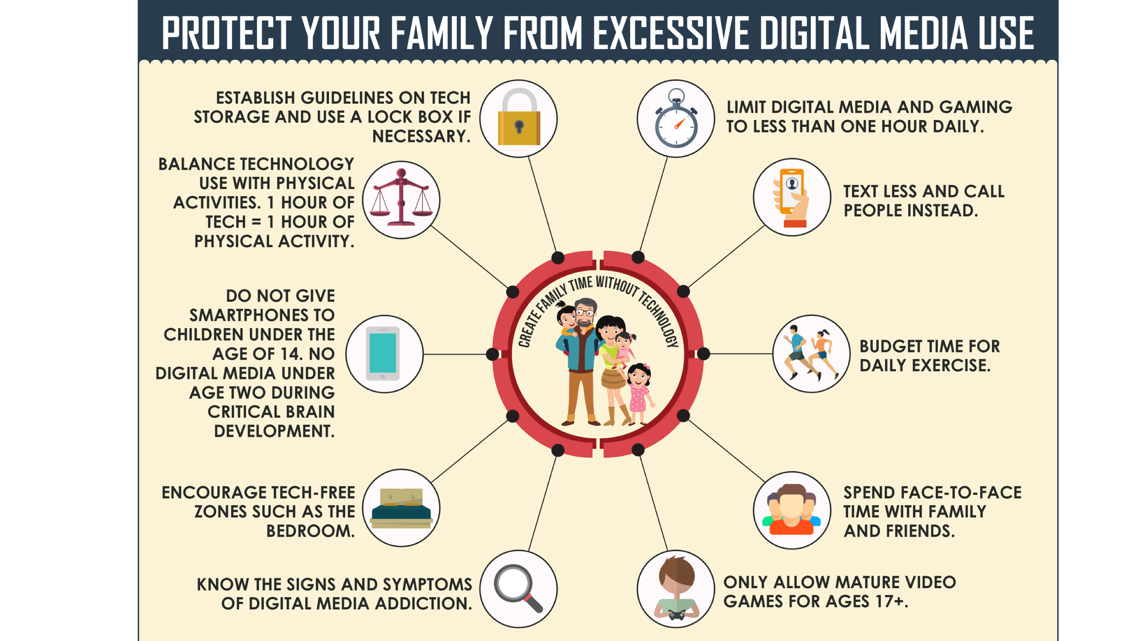
- Explain to your child the rationale for intervention. Be confident, yet kind. Remember that for many kids, electronics have been tantamount to an additional organ and removing it can feel like a surgery without anesthesia. Moreover, many children have never lived without media and will find it hard to even contemplate living without it, even though the media detox is only four weeks long. In short, expect your child to protest, or even possibly have a complete nuclear meltdown over the prospect. It might be appropriate to share relevant content of this paper to your child in a distilled form. Moreover, many teens should be afforded the opportunity to read this paper. We would not force the issue, however, if they show little interest.
- Ask for your child’s cooperation but not permission. You are the parent so be the parent. Dr. Doan developed the infographic on the next page to help guide your family through this process.

- Set up a start date and schedule. Many people find Mondays the best time to start as weekends are typically when there is more downtime and thus are often the most difficult times to start. This way, you will already be five days into digital detox by the time the weekend comes around.

- Perform a complete clean sweep of your child’s room. Remove all electronics except for possibly a radio.

- TV time. Although we recommend that TV viewing be included in the digital detox, if you feel that this would be best, we suggest that TV time be limited to family viewing only with a maximum of one hour per day.

- Obtain toys, games, and activities to fill in the void of not having screen time. Ensure that you are giving your child more access to games and activities. On the other hand, don’t worry about filling every minute of his/her time with these activities. It is okay for a child to be bored as this promotes creativity, a diminishing quality in many media-addicted children.

- Increase connection with friends and family members. Remember that increased connection with family members and parents during detox is extremely important. I strongly recommend fun one-on-one time with your child each day. Kersting (2016) noted that studies have shown that children who regularly eat dinner together with their families exhibit significantly less at-risk behavior, are less likely to develop mental health problems and disorders and are much more likely to do better in school. Please ensure the TV is off, and no one in the household brings any media to the table. Finally, never let your child eat alone in their room. Eating should be a social event.

- Have your child surrender his/her cell phone during digital detox. This will be the hardest thing for many teens. If having access to a phone is absolutely necessary, possibly for safety reasons, purchase a phone that has no access to the Internet and is not capable of texting. A second alternative is to disable texting and Internet functions on their smartphone, but this is much less desirable.

- Secure access to the Internet on the family computer and any handheld devices that the parent might have. If not done, most kids worth any grain of salt will conduct covert operations and will find a way to get their electronic cocaine. Remember that many kids and teens are a heck of a lot smarter about this stuff than we are.

- Get your kid outside and connecting with nature. As noted previously, nature is medicine to an over-aroused brain.

- Get your kid exercising. For some kids, this will be natural, but for many others, extremely difficult as an alarming number of children get virtually no exercise at all and are very out of shape. The extent to which the exercise is fun and/or is an activity your child actually likes is a win for everyone.

- Once you have completed the digital detox, it will be critical that you determine how much media will be allowed. Otherwise, things will definitely drift back to the same old patterns, and you will be back to square one. This is otherwise known as gravitation toward the mean. We recommend implementing a Media Contract to keep everybody honest and on the same page, such as the one cited by Kutcher (2017) but significantly modified – included at the end of this paper.

Treatment – Safety Guards/Monitoring and Support:
Consider resources as suggested and cited in Kutcher (2017) to help control/monitor access of content as well as supportive websites such as:
- www.commonsensemedia.com This site offers objective ratings and suggestions for all types of media. This is an excellent resource!
- www.screenagersmovie.com An award-winning film, produced by Delaney Ruston, M.D., that probes into the vulnerable corners of family life and depicts messy struggles over social media, video games, and academics.
- www.familysafemedia.com This site offers hardware for limiting access regarding both time and content. Hardware looks a little dated. The cost is about $69.
- www.getscreen.com This proposes to allow parents to monitor and set individual controls on all digital devices in the family, including setting time limits on television and video games. Connects to a smartphone and costs around $99.
- www.TimeTimer.com This site offers highly visible and easy to set timers.
- www.KidsBehavioralNerology.com This is Kutcher’s website, which contains information about many of the children who are particularly vulnerable to excessive screen time such as children with ADHD and ASD. Also available are updated summaries of the American Academy of Pediatrics’ media recommendations for children.
- https://meetcircle.com/ This device works with your home Wi-Fi and allows you to manage every connected device on your home network, both wireless and hard-wired and does not require any software on them. Lists for about $49.
- https://drdunckley.com/ This site offers, among other things, an excellent video of Dr. Dunckley’s explanation of the impact of media addiction and her rationale for her media reset, as well as details on how to implement the reset. Outstanding resource!
- https://gamequitters.com/ Game Quitters is a global support community for gamers and families with members from 95 countries. The organization provides coaching programs, a gamer respawn program, and a family reclaim program.
- https://www.olganon.org/home On-Line Gamers Anonymous®, founded in 2002, is a 12-step self-help group. As noted on their website, “We share our experience, strengths and hope to help and support each other recover and heal from problems resulting from excessive video game playing (gaming disorder).” This website is a “goldmine” of supportive links to numerous resources.
If in-home interventions do not improve your situation, then a referral to a professional specifically experienced in media addiction is appropriate.

In more extreme cases, residential treatment specifically tailored to address media addiction should be considered and among the best are:

- reSTART cofounded Dr. Hilarie Cash, PhD, Chief Clinical Director and Cosette Rae, CEO, Chief Executive Officer, MSW, LICSW, ACSW, CDWF: ReSTART specializes in behavioral addictions, Internet gaming disorder, video game addiction treatment, gambling, virtual reality, augmented reality, and excessive screen time and social media use. Care plans involve an in-depth examination into the factors leading to problematic screen use. In addition to adult treatment, reSTART offers in-depth residential intervention for youth 13-18 experiencing video game addiction, Internet gaming disorder, social media addiction, excessive screen time use, and often associated problems to include academic difficulties, depression, anxiety, ADD/ADHD, learning differences, and family conflict. I have personally toured their treatment center and found the staff to be among some of most compassionate, dedicated, and well-trained professionals serving residential clients I have ever met. Their facilities are innovative and state-of-the-art. Contact at:
Phone: 800.682.6934, email: admissions@restartlife.com, website: https://www.netaddictionrecovery.com/about-restart-tech-treatment/.

- Seahab founded by Dr. Kardaras: Seahab is an intensive experiential form of nature immersion therapy. Based on the very successful evidence-based principles of Outdoor Behavioral Healthcare (OBH), Seahab has proven to be very effective as an intensive intervention to help addicts shift out of self-destructive and toxic lifestyles. Contact Dr. Kardaras at: https://www.drkardaras.com/seahab.html.

- Launch House founded by Dr. Kardaras: Launch House offers full mental health services for adults and adolescents, including the attendant mental health and screen addiction issues that many young people face today. Services include outpatient counseling, psychiatric assessments and medication management, as well as more integrative and holistic modalities to help people meaningfully move forward in their lives. In addition, residential “digital detox” services are available for those who are overworked, overstressed, or have developed an over-dependence on screens and technology. At the Launch House’s digital detox program, the overstressed client can un-plug, detox, and calm their overstimulated adrenal system by grounding themselves into more balanced and healthy lifestyle patterns. Contact Dr. Kardaras at:
https://www.drkardaras.com/launch-house.html
- Michael Rich, M.D., M.P.H., is the Director of the Center on Media and Child Health.and mediatrician and the Center’s mission in understanding and responding to the effects of media on the physical, mental, and social health of children through research, translation, and education. https://digitalwellnesslab.org/
- Richard Freed, Ph.D., is a child and adolescent psychologist, author of the book Wired Child, and his insights have been featured in The New York Times, The Atlantic, The Wall Street Journal, The Washington Post, on NPR, and CNBC. - https://richardfreed.com/
- CAPTIVATED is a production of Media Talk 101 which was founded in 2005 by Phillip Telfer as an outreach to youth and families. Visit http://www.mediatalk101.org for helpful articles, videos, podcasts and other encouraging resources. - http://www.captivatedthemovie.com

By far, the greatest danger of Artificial Intelligence is that people conclude too early that they understand it.
- Eliezer Yudkowsky

Part Seven - Future Directions – A Word of Caution as We Embrace Artificial Intelligence

A
s forward thinkers, we are keenly aware of the new elephant in the room – and its name is Artificial Intelligence (AI). We all see concerns and dire warnings in the news about how we manage safe use of AI before it manages us. In developing this chapter, we decided to ask AI itself (ChatGPT) to critique this important topic and cited below is what it delivered, along with some of our thoughts. To be honest, the content is surprising, if not frighteningly good. We see both promise and peril and are of the opinion that if we remain keenly aware of the addictive potential of AI and its relationship to media consumption, we can learn to better partner with it rather than be controlled by it.

ChatGPT’s Analysis of AI

Artificial Intelligence (AI) has drastically transformed the media landscape, altering not only how content is created and distributed but also how it is consumed. As AI becomes more sophisticated, its impact on media addiction is increasingly becoming a significant concern. This essay explores the ways in which AI contributes to media addiction, the repercussions on mental and physical health, and the societal implications, supported by various academic references and journal citations.

Personalization and Engagement Algorithms

At the core of AI's impact on media addiction is its ability to personalize content. Algorithms curate feeds that trigger "frequent and extreme upward social comparison" (Hai.stanford.edu, 2023), leading to an erosion of self-esteem and decreased life satisfaction (Kuss and Griffiths, 2017). AI-driven platforms are designed to maximize user engagement, but this often comes at the cost of users' mental well-being. For instance, a systematic review by Khan and Khan (2021) emphasized that social media addiction increases stress, loneliness, and sadness, with anxiety being a prevalent outcome (National Library of Medicine, 2021).

Dopamine and Reward Systems

Dopamine, the neurotransmitter associated with the brain's reward system, is significantly manipulated by social media's AI algorithms. Lembke (2021) highlights in "Dopamine Nation" that the balance of indulgence in the modern age is often tipped towards overconsumption, facilitated by AI's ability to feed content that maximizes dopamine release (Goldman, 2021). (As neuroscientists, we are particularly concerned about potential damage to the brain due to excessive dopaminergic load).

Generative AI and Increased Addiction Potential

Generative AI, which creates personalized content, risks making social media platforms more addictive (Nature.com, 2023). This increased addiction potential can displace healthy activities such as exercise and sleep, leading to anxiety, depression, and sleep disorders (Twenge and Campbell, 2018). (We are particularly concerned that lonely people in particular will attach to AI in a very personal way and the cyber relationship will become infectious as the he/she of AI meets are every request for information and exploration in a very personalized way – “just for us”).

Physical Health Effects

Social media addiction (SMA), exacerbated by prolonged Internet use encouraged by AI, also has physical health effects. These include decreased physical activity, which is associated with various negative health outcomes (Frontiersin.org, 2021). The sedentary lifestyle promoted by SMA leads to increased health risks, further demonstrating the multi-faceted impact of AI on health (Vandelanotte et al., 2016).

Societal Implications

Beyond individual health, AI's role in media addiction has societal implications. OpenAI's executive Mira Murati raises concerns about AI's addictive nature and its potential to 'enslave' humanity, calling for a deeper understanding and mitigation of addictive technology's risks (Cryptopolitan.com, 2023). Furthermore, addiction statistics in 2023 indicate that social media addiction affects over 1.5 billion people worldwide, significantly impacting public health (Contentdetector.ai, 2023).

AI’s Conclusion about Itself

In conclusion, AI's impact on media addiction is multifaceted, affecting mental and physical health and having broader societal implications. As AI continues to evolve, it is crucial to balance technological advancements with the well-being of individuals and society. This necessitates a collaborative effort from AI developers, policymakers, and mental health professionals to mitigate the risks of media addiction. (AI has it right, the time is now, so let’s take this on sooner rather than later).

It's never too late to take a new path, to chase a new dream, to become a better version of yourself.
- Unknown.

Part eight - Closing Thoughts

I
n closing, we encourage parents to be proactive and take charge. Electronic media, in itself, is not at all a bad thing if kept in a healthy balance with connected living. It is our obligation as parents, educators, and professionals to help this generation of children responsibly use any form of media. We must wake up, not only individually, but as a society, to address this need. We remain optimistic that this can be done. We are all in this together and, connected with one another, we can ensure that our children grow to be happy, mature, and productive adults.

You have our permission to use and/or disseminate contents of this book as you deem appropriate, with the proviso that credit to the authors above cited at the beginning of this book is properly noted.

Media Contract
Non-negotiable rules

- You are a kind person. Being on an electronic device doesn’t change that. So, treat others on the internet the same way you would like to be treated. No cruelty and no bullying.

- You are a wonderful person just as you are, so don’t try to re-invent yourself on social media. You don’t have time to re-invent yourself while on social media, and you don’t have time to maintain both a real-life and an on-screen personality.

- Never post any text or picture that you wouldn’t want your grandmother or your prospective future employer to see.

- Always keep in mind that what you post is permanent, and there is no way to delete it once you hit that send button. Once it is out there in cyberspace, it’s out there forever and will serve as a character reference for future employers and, yes, even your own children someday.

- Do not live your life on your phone. You don’t have to document your entire life on your phone. The most important conversation should always be face-to-face.

- No pornography -ever! This is fantasy that misrepresents and cheapens caring and compassionate relationships. We don’t want you to get your information about these important topics from sites and people who don’t care about you. You can always come to us with questions about sexuality. If you can’t do that, we will make arrangements for you to talk confidentially with your doctor or another professional/adult.

- We will have ALL your usernames and passwords to all your accounts. We reserve the right to install parental controls and site blockers and must approve all your downloads before they are acquired.

- No texting or cell phone while driving. People can die! If you need to make a call or send/receive a text, pull over safely and do so. Any violation of this will immediately result in a six-month suspension of your driving privileges. No exceptions.

- You must obey all school rules about cell phones use and other technologies while on campus.

- No media at the dinner table.

Negotiable Rules
- Allowed to use electronic devices before starting homework:
Yes___ No___.
If yes, for how long? ________ Minutes.

- All computers and devices with internet connections must be used in a central location: Yes ___ No___.

- Multi-tasking actually makes homework take longer because you have to re-orient yourself after each interruption. To address this issue, you will -check one:
___ Divide your day into time slots to first do all of your homework
Then social media, then email.

___ Take a 10-minute break for every 50 minutes of work

___ Take a 1 to 2-minute break after every 10 - 15 minutes of work

Other:___________________________________

- During homework, you will keep your cell phone in a central location:
Yes ___ No ___.

- During homework time, you will turn ofF all notifications:
Yes ___ No ___.

- During homework time, you can listen to music (better if a radio):
Yes ___ No ___.

- Maximum screen time on school days: _________.

- Maximum screen time on non-school days: _________.

- At bedtime, the cell phone will (check one):
___ Remain in the bedroom
___ Be placed in a central location in the house

This agreement is valid until changes are mutually agreed upon.

________________ Date: ________
Person granted access to the technology

________________ Date: ________
Person(s) who owns the technology

References

Alexander, B. “Addiction: “The View from the Rat Park,” www.Brucekalaxander.com, 2010, http://brucekalexander.com/articles-speeches/rat-park/148-addiction-the-view-from-rat-park.

American Academy of Pediatrics, “Children, Adolescents and the Media: Council on Communication and the Media,” Pediatrics 132, no.5 (2013): 58-61.

PubMed link: https://www.ncbi.nlm.nih.gov/pubmed/28448255
doi link: http://doi.org/10.1542/peds.2013-2656

Anderson, C. et al., “Violent Video Game Effects on Aggression, Empathy, and Prosocial Behavior in Eastern and Western Countries: A Meta-Analytic Review.” Psychological Bulletin 136, no.2 (March 2010): 151 – 173.

PubMed link: https://www.ncbi.nlm.nih.gov/pubmed/20192553
doi link: https://doi.org/10.1037/a0018251

Atladottir, H. et al., “Time Trends in Reported Diagnosis of Childhood Neuropsychiatric Disorders: A Danish Cohort Study,” Archives of Pediatrics & Adolescent Medicine 161, no. 2 (February 2007): 193-98, doi:10.1001.

PubMed link: https://www.ncbi.nlm.nih.gov/pubmed/17283306
doi link: https://doi.org/10.1001/archpedi.161.2.193

Bandura, A., et al., “Transmission of Aggression through Imitation of Aggressive Models,” Journal of Abnormal and Social Psychology 63 (1961): 575-582, http://psychchclassics.yorku.ca/Bandura/bobo.htm.

PubMed link: https://www.ncbi.nlm.nih.gov/pubmed/13864605

Bartholow, B. et al., “Chronic Violent Video Game Exposure and Desensitization to Violence: Behavioral and Event-Related Brain Potential Data,” Journal of Experimental Social Psychology 42, no. 4 (July 2006): 532-39, doi:10,1016/j.jesp.2005.08.006.

doi link: http://doi.org/10.1016/j.jesp.2005.08.006

Behncke, I. “Evolution's gift of play, from bonobo apes to humans,” TED TALK 2011,
https://www.ted.com/talks/isabel_behncke_evolution_s_gift_of_play_from_bonobo_apes_to_humans?language=en#t-316668

Becker, M. et al., “Media Multitasking is Associated with Symptoms of Depression and Social Anxiety,” Cyberpsychology, Behavior and Social Networking 16, no. 2 (February 2013): 132-35, doi:10.1089/cyber.2012.0291.
PubMed link: https://www.ncbi.nlm.nih.gov/pubmed/23126438
doi link: https://doi.org/10.1089/cyber.2012.0291

Belk, R. “Worldly Possessions: Issus and Criticisms,” Advances in Consumer Research 10 (1983): 514-19.

Blue Cross and Blue Shield Study (2018).
https://www.bcbs.com/the-health-of-america/reports/major-depression-the-impact-overall-health

Brown.edu. (2023). What Makes TikTok so Addictive?: An Analysis of the Mechanisms.

Cajochen, C. et. al., “Evening Exposure to a Light-Emitting Diodes (lED)-Backlit Computer Screen Affects Circadian Physiology and Cognitive Performance,” Journal of Applied Physiology 110, no. 5 (May 2011): 1432-38, doi:10.1152/japplphysiol.00165.2011.

PubMed link: https://www.ncbi.nlm.nih.gov/pubmed/21415172
doi link: https://doi.org/10.1152/japplphysiol.00165.2011

Cacioppo, J. “The Lethality of Loneliness,” Ted Talk 2013, https://www.youtube.com/watch?v=_0hxl03JoA0

Cacioppo, J. et al., “Day-to-Day Dynamics of Experience-Cortisol Associations in a Population-Based Sample,” PNAS 103 no. 45 (October 2006): 17058-17063.

PubMed link: https://www.ncbi.nlm.nih.gov/pubmed/17075058
doi link: https://doi.org/10.1073/pnas.0605053103

Cacioppo, J. et al., (2008). Loneliness: Human Nature and the Need for Social Connections. New York, NY: W. W. Norton & Company.

Cacioppo, J. et al., “Perceived Social Isolation Makes Me Sad: 5-Year Cross-Lagged Analyses of Loneliness and Depressive Symptomatology in the Chicago Health, Aging, and Social Relations Study,”
Psychology and Aging 25, no.2 (2010): 453-463.

PubMed link: https://www.ncbi.nlm.nih.gov/pubmed/20545429
doi link: https://doi.org/10.1037/a0017216

Cash, H. & McDaniel, K. (2008). Video Games and Your Kids: How Parents Stay in Control. Issues Press

Christakis, D. A. (2020). Early Media Exposure and Autism Spectrum Disorder: Heat and Light. JAMA Pediatrics. DOI: 10.1001/jamapediatrics.2020.0659

Chrousos, G. et al., “Metabolic Consequences of Stress during Childhood and Adolescence,” Metabolism, Clinical and Experimental 61, no. 5 (May 2012): 611-19, doi:10.1016/j.metbol.2011.10.005.

PubMed link: https://www.ncbi.nlm.nih.gov/pubmed/22146091
doi link: https://doi.org/10.1016/j.metabol.2011.10.005

Cigna (2018).
https://www.cigna.com/newsroom/news-releases/2018/new-cigna-study-reveals-loneliness-at-epidemic-levels-in-america

Cohen S. et al., The McGill Quality of Life Questionnaire: a measure of quality of life appropriate for people with advanced disease. A preliminary study of validity and acceptability. Palliative Medicine 9, no. 3 (1995):207–219.

PubMed link: https://www.ncbi.nlm.nih.gov/pubmed/7582177
doi link: https://doi.org/10.1177/026921639500900306

Contentdetector.ai. (2023). 10+ Key Social Media Addiction Statistics in 2023.

Cryptopolitan.com. (2023). Open AI Executive Highlights Risks of AI Addiction and Human Enslavement.

Cox, E. et al., “Trends in the Prevalence of Chronic Medication Use in Children: 2002-2005,” Pediatrics 122, no. 5 (November 1, 2008): e1053-e1061, doi:10.1542/peds.2008-0214.

PubMed link: https://www.ncbi.nlm.nih.gov/pubmed/18977954
doi link: https://doi.org/10.1542/peds.2008-0214

Datenbur et al., “The Effects of Picture Motion on Emotional Responses,” Journal of Broadcasting & Electronic Media 42, no.1 (May 18, 2009): 113-127.

doi link: https://doi.org/10.1080/08838159809364437

Davies, W (2016). The Happiness Industry: How the Government and Big Business Sold Us Well-Being. New York: Verso, 106.

DeAngelis, T. “Therapy Gone Wild,” American Psychological Association 44, no. 8 (September 2013): 48.
NOTE: This is actually in Monitor on Psychology, the magazine of the APA

Doan, A. (2012). Hooked on Games. Coralville, IA: F.E.P. International, Inc.
Dobnik, V. (2004, April 7). “Surgeons May Err Less by Playing Video Games.” Retrieved September 1, 2005, from NBC News: www.nbcnews.com/id/4685909/ns/technology_and_science-games/t/surgeons-may-error-less-playing-video-games/#.VW5IIWCQb0c.
Dunckley, V. “Electronic Screen Syndrome: An Unrecognized Disorder?” Psychology Today, July 23, 2012.
PubMed link: https://www.ncbi.nlm.nih.gov/pubmed/

Dunckley, V. (2015). Reset your Child’s Brain. Novato, CA: New World Library.
Eickhoff, E., Yung, K., Davis, D. L., Bishop, F., Klam, W. P., & Doan, A. P. (2015). Excessive Video Game Use, Sleep Deprivation, and Poor Work Performance Among U.S. Marines Treated in a Military Mental Health Clinic: A Case Series. Military medicine, 180(7), e839–e843. https://doi.org/10.7205/MILMED-D-14-00597

Engelhardt, C. et al., “This is Your Brain on Violent Video Games: Neural Desensitization to Violence Predicts Increased Aggression Following Violent Video Game Exposure,” Journal of Experimental Psychology 47, no 5 (September 2011): 1033-36, doi:101016/j.jesp.2011.03.027.
Evangelista, B. Attention Loss Feared as High-Tech Rewires the Brain,” San Francisco Chronicle, November 2009.
“Facing the Screen Dilemma: Young Children, Technology and Early Education,” Campaign for a Commercial Free Childhood, October 2012, https://www.commercialfreechidhood.org/screendelemma
Farchian, T. “Depression: Our Modern Epidemic,” Marina Times, April 2016.
Felitti, V. et al., (2014) “Chadwick’s Child Maltreatment: Sexual Abuse and Psychological Maltreatment,” Volume 2 of 3, Fourth Edition.
Felitti, V. “Adverse Childhood Experiences and the Risk of Depressive Disorder in Childhood,” Journal of Affective Disorders 82 (November 2004): 217-225.

Freeman, B. “Researchers Examine Video Gaming’s Benefits.” (n.d.). Retrieved June 2, 2015 from the U.S. Department of Defense: www.defense.gov/news/newsarticle.aspx?id=57695.

Frontiersin.org. (2021). The Relationship of Social Media Addiction With Internet Addiction and Health-Related Quality of Life: A Study in Six Asian Countries.

Gentile, D. et al., “Violent Content in Video Games Effects on Children and Adolescents: A Review of the Literature, “Minerva Pediatrica 57, no. 6 (December 2005): 337-58.

Gilbert, N. “Green Space: A Natural High,” Nature 531 (March 2016): 56-57.

Gilman, L., Cage, D. N., Horn, A., Bishop, F., Klam, W. P., & Doan, A. P. (2015). Tendon rupture associated with excessive smartphone gaming. JAMA internal medicine, 175(6), 1048–1049. https://doi.org/10.1001/jamainternmed.2015.0753

Goldman, B. (2021). The Addictive Potential of Social Media. Scope.

Goleman, D. “Emotional Intelligence: Mixed Model,” Universal Class, assessed November 16, 2016, https://www.universalclass.com/articles/psychology/emotional-intelligence-mixed-model.htm

Gray, P. “Declining Student Resilience: A Serious Problem for Colleges,” Psychology Today, September 22, 2015.

Greenfield, S. (2015). Mid Change: How digital Technologies Are Leaving Their Mark on Our Brains. New York, NY: Random House.
Griffiths, M. (2011). https://www.theguardian.com/technology/gamesblog/2011/sep/22/game-transfer-phenomena./
Guangbheng, D. et al., “Impaired Inhibitory Control in Internet Addiction Disorder: A Functional Magnetic Resonance Imaging Study: Psychiatry Research 203, nos. 2-3 (September 2012): 153-158, doi:10.1016/jpscychresns.2012.02.001.
PubMed link: https://www.ncbi.nlm.nih.gov/pubmed/22892351
doi link: https://doi.org/10.1016/j.pscychresns.2012.02.001
Hai.stanford.edu. (2023). A Psychiatrist’s Perspective on Social Media Algorithms and Mental Health.

Han, D. et al. (2011). Brain activity and desire for internet video game play
Comparative Psychiatry. Jan–Feb; 52(1).
https://www.ncbi.nlm.nih.gov/pmc/articles/PMC3039876/
(accessed April 10, 2021).

Hari, J. “Everything You Think You Know about Addiction Is Wrong.” TED Global London, 14:42. June, 2015. https://www.ted.com/talks/johann_hari_everything_you_think_know_about_addiciton_is_wrong?language=en
Hari, J. (2018). Lost Connections: Uncovering the Real Causes of Depression – And the Unexpected Solutions. Berryville, VA: Berryville Graphics, Inc.
Harlé B. (2019). Intensive early screen exposure as a causal factor for symptoms of autistic spectrum disorder: The case for «Virtual autism». Trends in neuroscience and education, 17, 100119. https://doi.org/10.1016/j.tine.2019.100119

Heffler, K. F., Sienko, D. M., Subedi, K., McCann, K. A., & Bennett, D. S. (2020). Association of Early-Life Social and Digital Media Experiences With Development of Autism Spectrum Disorder-Like Symptoms. JAMA pediatrics, 174(7), 690–696. https://doi.org/10.1001/jamapediatrics.2020.0230

Higuchi, S. et al., “Effects of VDT Tasks with a Bright Display at Night on Melatonin, Core Temperature, Heart Rate, and Sleepiness,” Journal of Applied Physiology 94, No. 5 (May 2003) 1773-76, doi:10.1152/Jappphysiol.00616.2002.
PubMed link: https://www.ncbi.nlm.nih.gov/pubmed/12533495
doi link: https://doi.org/10.1152/japplphysiol.00616.2002
Hoffman, H.G., Patterson, D.R., Carrougher G.J., Sharar S.R. Effectiveness of virtual reality-based pain control with multiple treatments. Clinical Journal of Pain. 2001 Sep;17(3):229-35. doi: 10.1097/00002508-200109000-00007. PMID: 11587113.

Indiana University School of Medicine, “Violent Video Games Alter Brain Function in Young Men,” Science Daily December 1m 2001, www.sciencedaily.com/releases/2011/11/111130095251.htm.
Internet Live Stats, website, www.internetlivestats.com
Ivory, J. and Kalyanaraman, S. “The Effects of Technological Advancement and Violent Video Content in Video Games on Players’ Feelings of Presence, Involvement, Physiological Arousal, and Aggression,” Journal of Communication, 57, no. 3 (September 2007): 532-55, doi:10.1111/j.1460-2466.2007.00356.x.
doi link: http://doi.org/10.1111/j.1460-2466.2007.00356.x
Kasser, T. (2003). The High Price of Materialism. Cambridge: MIT Press.
Kardaras, N. (2016). Glow Kids. New York, NY: St. Martin’s Press.
Khan, S., & Khan, R. A. (2021). Social media addiction among teenagers in Pakistan. National Library of Medicine, 13(2), 44-50.

Kersting, T. (2016). Disconnected: How to Reconnect our Digitally Distracted Kids. Independent Publishing Platform.
Koepp, M. et al., “Evidence for Striatal Dopamine Release during a Video Game.” Nature, 393, no. 6682 (May 21, 1998): 266-268, doi:10.1018/30498.
PubMed link: https://www.ncbi.nlm.nih.gov/pubmed/9607763
doi link: https://doi.org/10.1038/30498
Koenig H. et al., “Attendance at religious services, interleukin-6, and other biological parameters of immune function in older adults,” International Journal of Psychiatry Medicine, no. 27 (1997): 233–250.
PubMed link: https://www.ncbi.nlm.nih.gov/pubmed/9656726
doi link: https://doi.org/10.2190/40NF-Q9Y2-0GG7-4WH6
Kuss, D. J., & Griffiths, M. D. (2017). Social Networking Sites and Addiction: Ten Lessons Learned. International Journal of Environmental Research and Public Health, 14(3), 311.

Louv, R. (2005). Last Child in the Woods. New York: Workman Publishing.
Loyola University Health System. (2008, March 22). “Virtual-Reality Video Games to Help Burn Patients Play Their Way to Pain Relief.” Retrieved June 20, 2014, from Science Daily: www.sciencedailly.com/releases/2008/03/080319512774.htm
Mark, G. et al., “Stress and Multitasking in Everyday College Life: An Empirical Study of Online Activity,” CHI’14 Proceedings of the SIGCHI on Human Factors in Computing Systems (ACM Press, 2014): 41-50,doi:10.1145/2556288.2557361.
doi link: https://doi.org/10.1145/2556288.2557361
Marmot et al., “When reciprocity fails: effort-reword imbalance in relation to coronary heart disease and health functioning within the Whitehall II study,” Occupational and Environmental Medicine, 59 (2002): 777-784, doi:10.1136/oem.59.11.777.
PubMed link: https://www.ncbi.nlm.nih.gov/pubmed/12409537
doi link: https://www.ncbi.nlm.nih.gov/pmc/articles/PMC1740240/
Monbiot, G., “The Age of Loneliness is Killing Us,” Guardian, October 14, 2014., https://www.the gurardian.com/commentisfee/2014/14/age-of-loneliness-killing-us, as accessed September 16, 2016
Moreno, C. et al., “National Trends in the Outpatient Diagnosis and Treatment of Bipolar Disorder in Youth,” Archives of General Psychiatry 64, no. 9 (September 2007): 132-139, doi:10.1001/archpsyc.64.9.1032.
Nass, C. (2013). “Are You Multitasking Your Life Away?” https://www.youtube.com/watch?v=PriSFBu5CLs
Nature.com. (2023). Social Media: Generative AI Could Harm Mental Health.

Nepomnaschy, P. et al., “Stress and Female Reproductive Function: A Study of Daily Variations in Cortisol, Gonadotrophins, and Gonadal Steroids in a Rural Mayan Population,” American Journal of Human Biology: The Official Journal of the Human Biology Council 16, no. 5 (October 2004): 523-32, doi:10.1002/ajhb.20057.
doi link: http://doi.org/10.1001/archpsyc.64.9.1032
Ng, S. et al., “Addiction to the Internet and Online Gaming,” Cyberpsychology & Behavior: The Impact of the Internet, Multimedia and Virtual Reality on behavior and Society 8, no. 2 (April 2005): 110-13, doi:10.1089/cpb.2005.8.110.
PubMed link: https://www.ncbi.nlm.nih.gov/pubmed/15938649
doi link: https://doi.org/10.1089/cpb.2005.8.110
Ophir, E. et al., “Cognitive Control in Media Multitaskers,” Proceedings of the National Academy of Sciences of the Unties States of America 106:37: (2009), 15583-15587.
PubMed link: https://www.ncbi.nlm.nih.gov/pubmed/19706386
doi link: https://doi.org/10.1073/pnas.0903620106
Palladino, L. (2015). Parenting in the Age of Attention-Snatchers: A step-by-step Guide to Balancing Your Child’s Use of Technology. Boston, MA: Shambhala.

Pederson, T. “Hyper-Texting Associated with Health Risks for Teens,” Psych-Central, October 6, 2015.

Pervanidou et al., “Stress and Obesity/Metabolic Syndrome in Childhood and Adolescence,” International Journal of Pediatric Obesity: IJPO: An Official Journal of the International Association for the Study of Obesity, 6, Suppl 1 (September 2011): 21-28, doi:10.3109/17477166.2011.615996.
PubMed link: https://www.ncbi.nlm.nih.gov/pubmed/21905812
doi link: https://doi.org/10.3109/17477166.2011.615996

Pinker, S. (2015). The Village Effect: Why Face-to-Face Contact Matters. London: Atlantic Books.
Rideout, V. et al., “Zero to Six: Electronic Media in the Lives of Infants, Toddlers and Preschoolers,” 2003, http//eric.ed.gov/?id=ED482302; D.A. Christakis et al., “Television Video, and Computer Game Usage in Children under 11 years of Age,” Journal of Pediatrics 145, no.5 (2004): 652-56.
PubMed link: https://www.ncbi.nlm.nih.gov/pubmed/15520768
doi link: https://doi.org/10.1016/j.jpeds.2004.06.078

Rideout, V. et al., “Generation M2: Media in the Lives of 8- to 18-Year Old’s,” Kaiser Family Foundation Study, 2010, http://kff.org/other/poll-finding/report-generation-m2-media-in-the-lives/

Rizzolatti, G. et al., “The Mirror-Neuron System,” Annual Review of Neuroscience 27 (2004): 169-192. This is a technical article. For an informative, plain-language presentation, visit Nova at PBS (air date January 25, 2005), www.pbs.org/wgbh/nova/body/morror-neurons.html
PubMed link: https://www.ncbi.nlm.nih.gov/pubmed/15217330
doi link: https://doi.org/10.1146/annurev.neuro.27.070203.144230

Rosen, L. (2012). iDisorder: Understanding Our Obsession with Technology and Overcoming Its Hold on Us. New Your, NY: Palgrave Macmillan.

Sapolsky, R. (2002). A Primate’s Memoir. London: Vintage.

Sapolsky, R. “Cortisol Concentrations and the Social Significance of Rank Instability Among Wild Baboons,” Psychoneuoendochrinology 17, no. 6 (November 1992): 701-709.
PubMed link: https://www.ncbi.nlm.nih.gov/pubmed/1287688

Shayer, M. et al., “Thirty Years on – a Large Anti-Flynn Effect? The Piagetian Test Volume & Heaviness Norms 1975-2003,” British Journal of Educational Psychology 77, no. 1 (March 2007): 25-41, doi:10:1348/000709906X96987.
doi link: https://doi.org/10.1348/000709906X96987

SSI Annual Statistical Report, 2012 (Washington, DC: Social Security Administration, July 2013, http://www.ssa.gov/policy/docs/statcomps/ssi_asr/2012/ssi_asr/2012/ssi_asr12.pdf

Strathearn, L. “Maternal Neglect: Oxytocin, Dopamine and the Neurobiology of Attachment,” Journal of
Neuroendocrinology 23, no. 11 (November 2011): 1054-65, doic:10.1111/j.1365-2826.2011.02228.x.
PubMed link: https://www.ncbi.nlm.nih.gov/pubmed/21951160
doi link: https://doi.org/10.1111/j.1365-2826.2011.02228.x

Strawbridge, W. et al., Frequent attendance at religious services and mortality over 28 years. Am J Public Health, No. 87 (1997): 957–961.
PubMed link: https://www.ncbi.nlm.nih.gov/pubmed/9224176

Strohle, A., “Physical Activity, Exercise, Depression, and Anxiety Disorders,” Journal of Neural Transmission 116, no. 6 (June 2009): 777.
PubMed link: https://www.ncbi.nlm.nih.gov/pubmed/18726137
doi link: https://doi.org/10.1007/s00702-008-0092-x

Sutherland, J. (2014). Jumbo: The Unauthorized Biography of a Victorian Sensation. London: Aurum Press.

Suzuki, A. “[Emotional functions of the insula],” Brain and Nerve = Shinkei Kenkyo no Shinpo 64, no. 10 (October 1, 2012): 1103-12.
PubMed link: https://www.ncbi.nlm.nih.gov/pubmed/23037601

The ABC of Gender Equality in Education: Aptitude, Behavior, Confidence.” Retrieved July 21, 2015 from the Organization for Economic Cooperation and Development: www.oecd.org/publications/the-abc-of-gender-equality-in-education-9789264229945-en.htm.p.43.

The Guardian (2011). https://www.theguardian.com/technology/gamesblog/2011/sep/22/game-transfer-phenomena

Turner, A. (2017). Breaking the Feedback Loop: How I Liberated myself from Internet Addiction and you can too. Lexington, KY: Phanarian II.

Twenge, J. (2017). iGen: Why Today’s Super-Connected Kids Are Growing Up Less Rebellious, More Tolerant, Less Happy – and Completely Unprepared for Adulthood. New York, NY: Atria.

Twenge, J., “Time Period and Birth Cohort Differences in Depressive Symptoms in the U.S., 1982-2013,” Social Science Research 121, no. 2 (June 2014): 437-454.
doi link: http://doi.org/10.1007/s11205-014-0647-1

Twenge, J. (2006). Generation Me. New York, NY: Free press.

Twenge, J. M., & Campbell, W. K. (2018). Associations between screen time and lower psychological well-being among children and adolescents: Evidence from a population-based study. Preventive Medicine Reports, 12, 271-283.

Wallenius, M., “Salivary Cortisol in Relation to the Use of Information and Communication Technology (ICT) in School-Aged Children,” Psychology, no. 1 (2010): 88-95, doi:10.4236/psych.2010.12012.
doi link: http://doi.org/10.4236/psych.2010.12012

Weinschenk, S. “100 things You Should Know About People: #8 – Dopamine Makes You Addicted to Seeking Information – The Team W Blog. The Team W Blog (2009).

Weng, Chung-bo et al., “A voxel-based morphometric analysis of brain gray matter in online game addicts,” Zhangua yi xue za zhi 92, no. 45 (December 4, 2012): 3221-23.
PubMed link: https://www.ncbi.nlm.nih.gov/pubmed/23328472

Wilson, G. (2014). Your Brain on Porn. UK: Commonwealth Publishing.

Zimbardo, P. and Coulombe, N. (2016). Man Interrupted. Newburyport, MA: Conari Press.

